**An Internship Report**

**On**

**Salesforce AI Developer Virtual Internship**

**Submitted In accordance with the requirement for the degree of**

**BACHELOR OF TECHNOLOGY**

**INFORMATION TECHNOLOGY**

**Submitted by**

**TAMMA SREYA (218X1A1260)**

**BADUGU RENUKA (218X1A1203)**

**SAMPATHI KALYAN CHAKRAVARTHI (218X1A1231)**

**NAKKALA CHAITANYA KRISHNA (228X5A1204)**



**DEPARTMENT OF INFORMATION TECHNOLOGY**

**KALLAM HARANADHAREDDY INSTITUTE OF TECHNOLOGY  
(AUTONOMOUS)**

**Approved by (AICTE, New Delhi; Permanently Affiliated to JNTU KAKINADA)**

**Accredited by NAAC with an ‘A’ Grade**

**NH – 16, Chowdavaram, Guntur – 522019 (A.P)**

**ACADEMIC YEAR: 2024-2025**

**Project Title : Garage Management System**.

**Project Overview** : The Garage Management System (GMS) is designed to streamline daily operations in automotive repair shops, providing a comprehensive solution for managing customer interactions, vehicle repairs, inventory, and billing. This system offers a central platform where staff can easily track service requests, schedule appointments, and maintain detailed records of repairs, ensuring nothing slips through the cracks.

With features like automated reminders, parts tracking, and job status updates, GMS not only enhances operational efficiency but also improves customer satisfaction by providing transparency and timely communication. Furthermore, the system integrates with accounting tools, enabling seamless invoicing and payment processing, which simplifies financial management for the business.

By providing real-time insights into repair status, resource utilization, and inventory levels, GMS empowers garage owners and managers to make informed decisions, optimize workflow, and reduce downtime. This all-in-one solution helps garages focus on what matters most: delivering high-quality service, fostering customer loyalty, and growing the business. With its scalability, GMS is suitable for both small shops and large automotive service chains, making it an essential tool for garages aiming for success in a fast-paced industry.

**Salesforce**

**Introduction:**  
  
Are you new to Salesforce? Not sure exactly what it is, or how to use it? Don’t know where you should start on your learning journey? If you’ve answered yes to any of these questions, then you’re in the right place. This module is for you.

Welcome to Salesforce! Salesforce is game-changing technology, with a host of productivity-boosting features, that will help you sell smarter and faster. As you work toward your badge for this module, we’ll take you through these features and answer the question, “What is Salesforce, anyway?”.

**What Is Salesforce?**

Salesforce is your customer success platform, designed to help you sell, service, market, analyze, and connect with your customers.

Salesforce has everything you need to run your business from anywhere. Using standard products and features, you can manage relationships with prospects and customers, collaborate and engage with employees and partners, and store your data securely in the cloud.

**Objectives:**

**Goals :** The GMS project aims to enhance operational efficiency, improve customer service, optimize inventory management, provide real-time data insights, ensure scalability, promote collaboration, and increase transparency and accountability.

**Expected Outcomes :** Expected outcomes include a 30% decrease in manual tasks, 20% reduction in errors, 25% increase in customer retention, 15% increase in repeat business, 20% reduction in service delays, 15% reduction in inventory costs, 25% improvement in decision-making accuracy, 10% increase in profitability, support for a 50% increase in business volume, 30% reduction in communication issues, 20% increase in team efficiency, 25% reduction in service disputes, and 15% increase in employee satisfaction.

**Key Features :**

1. **User Management**:
   * **Multiple User Roles**: Systems like Garage Buddy support multiple user accounts, allowing mechanics and employees to have their own personalized access. This is crucial for managing different roles such as managers, mechanics, receptionists, and supervisors.
2. **Service Tracking**:
   * **Detailed Service Logs**: GMS solutions like Garage Buddy help maintain a complete history of each vehicle’s services, from routine maintenance to complex repairs. This ensures better customer service and helps in tracking service dates.
3. **Inventory Management**:
   * **Vehicle Spare Parts**: GMS allows for efficient management of vehicle spare parts inventory. Supervisors can check inventory levels and track which vehicles are being serviced.
4. **Appointments**:
   * **Appointment Management**: GMS enables users to book appointments in advance, making it easier to schedule services. This helps in managing the workflow and reducing wait times.
5. **Reports and Dashboards**:
   * **Data Visualization**: GMS solutions provide detailed reports and dashboards for real-time tracking of business operations. These tools help in analyzing service performance metrics and making informed decisions.

**Milestone 1:** Creating Developer Account

**Creating a developer org in salesforce.**

1. **Go to**[**https://developer.salesforce.com/signup**](https://developer.salesforce.com/signup)
2. **On the sign up form, enter the following details :**

**[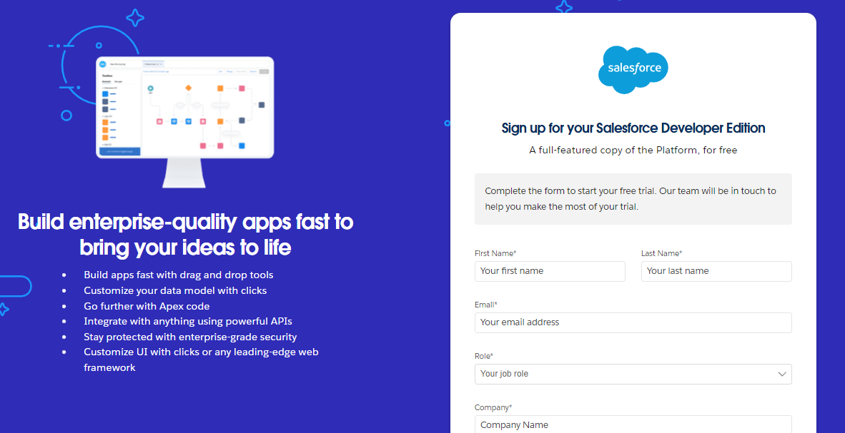](https://developers.salesforce.com/Signup*)**

**Then Fill the Details**

1. **First name & Last name :** Internship Project
2. **Email :** 218x1a1260@khitguntur.ac.in
3. **Role :** Developer
4. **Company :** KHIT
5. **County :** India
6. **Postal Code :** 522211
7. **Username :** garagemanagementsystem@khit.com

**Account Activation**

1. Go to the inbox of the email that you used while signing up. Click on the verify account to activate your account. The email may take 5-10mins.

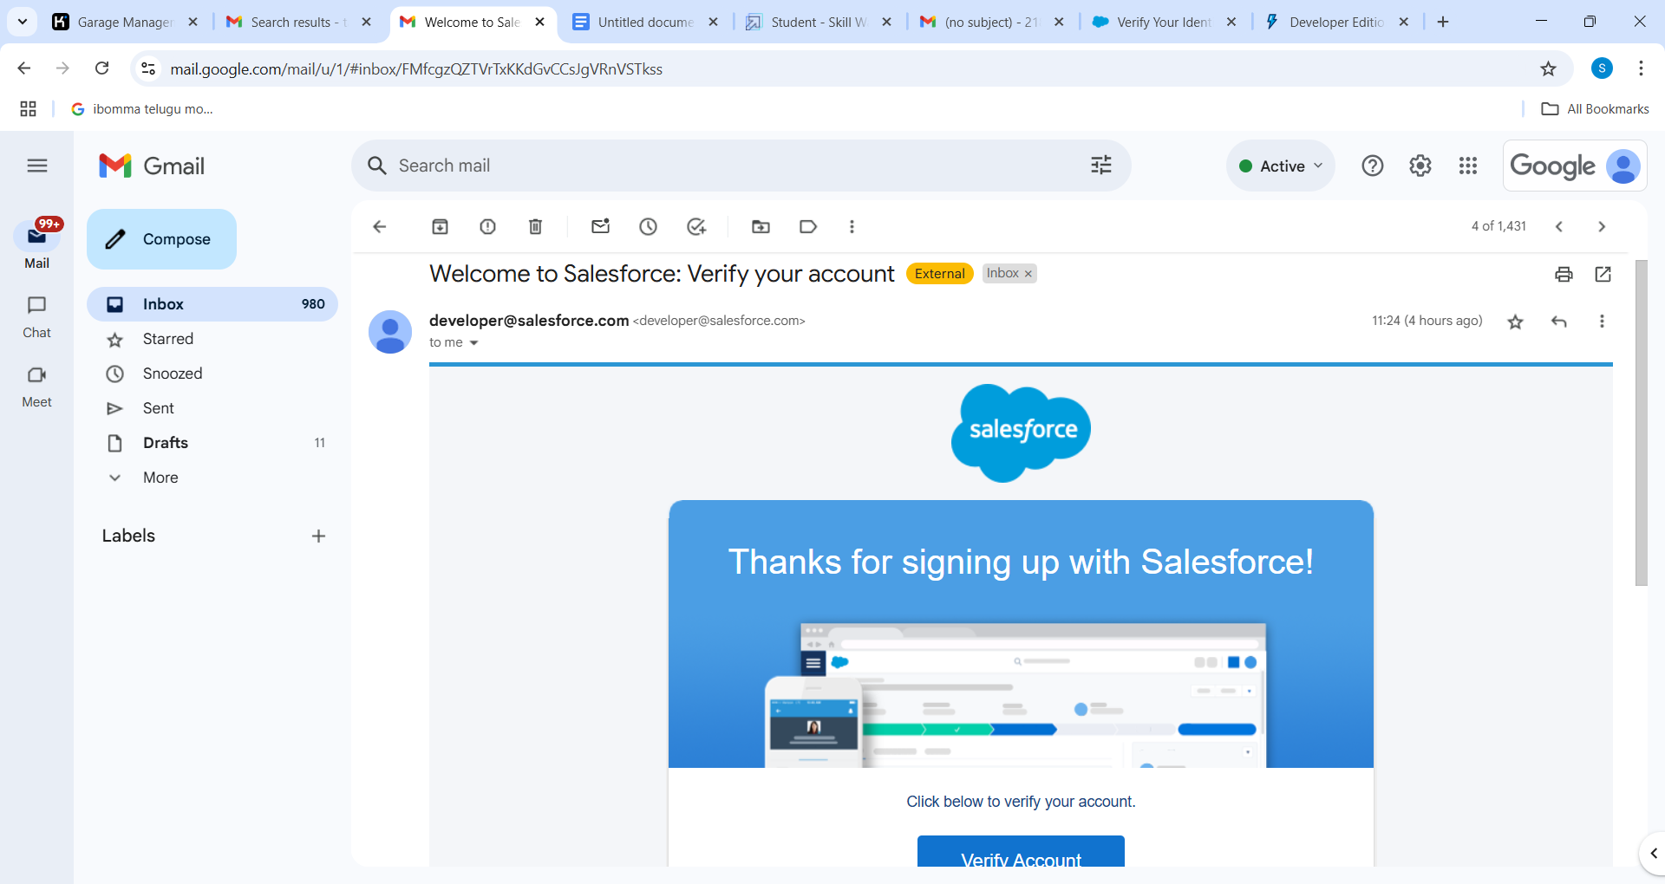

1. Click on Verify Account
2. Give a password and answer a security question and click on change password.

**Milestone 2 :** Object

**Create Customer DetailsObject**

To create an object:

1. From the setup page >>  Click on Object Manager >> Click on Create >> Click on Custom Object.
2. Enter the label name >> Customer Details
3. Plural label name >>  Customer Details
4. Enter Record Name Label and Format

* Record Name >>  Customer Name
* Data Type >> Text

1. Click on Allow reports and Track Field History,
2. Allow search >> Save.

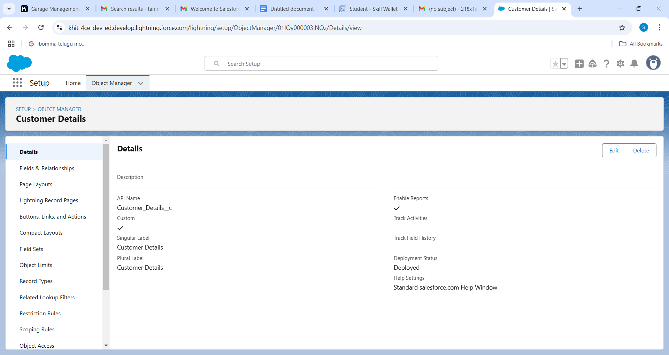

**Create Appointment Object**

To create an object:

1. From the setup page >> Click on Object Manager >> Click on Create >> Click on Custom Object.
2. Enter the label name >> Appointment
3. Plural label name >> Appointments
4. Enter Record Name Label and Format

* Record Name >> Appointment Name
* Data Type >> Auto Number
* Display Format >> app-{000}
* Starting number >> 1

1. Click on Allow reports and Track Field History,
2. Allow search >> Save.

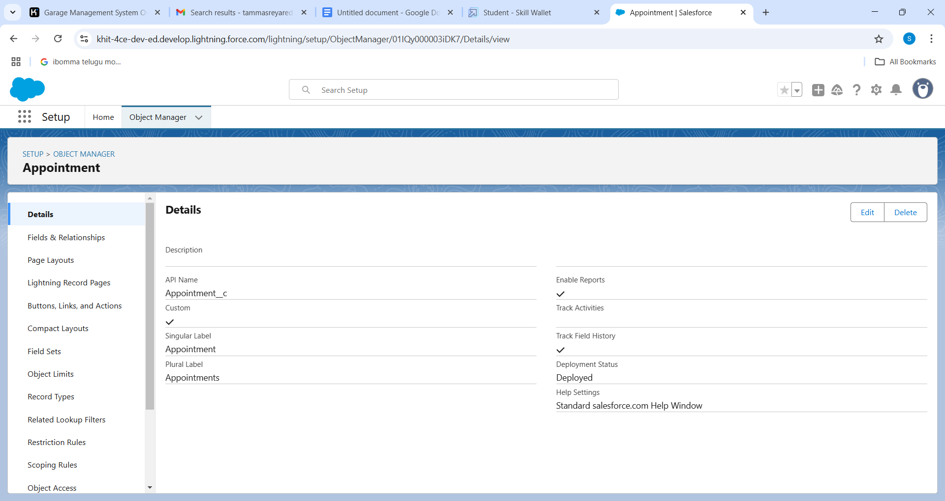

**Create Service records Object**

To create an object:

1. From the setup page  >>  Click on Object Manager  >>  Click on Create  >>  Click on Custom Object.
2. Enter the label name >> Service records
3. Plural label name >> Service records
4. Enter Record Name Label and Format

* Record Name >>Service records Name
* Data Type  >>  Auto Number
* Display Format  >> ser-{000}
* Starting number  >>  1

1. Click on Allow reports and Track Field History,
2. Allow search >>  Save

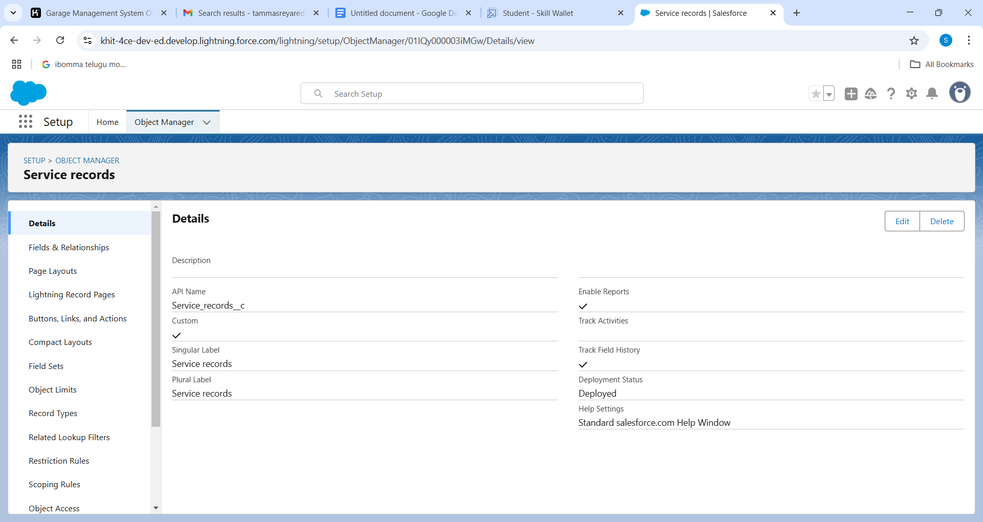

**Create Billing details and feedback Object**

To create an object:

1. From the setup page  >> Click on Object Manager  >> Click on Create  >> Click on Custom Object.
2. Enter the label name >> Billing details and feedback
3. Plural label name >> Billing details and feedback
4. Enter Record Name Label and Format

* Record Name >> Billing details and feedback Name
* Data Type  >> Auto Number
* Display Format  >>  bill-{000}
* Starting number  >> 1

1. Click on Allow reports and Track Field History,
2. Allow search  >>  Save

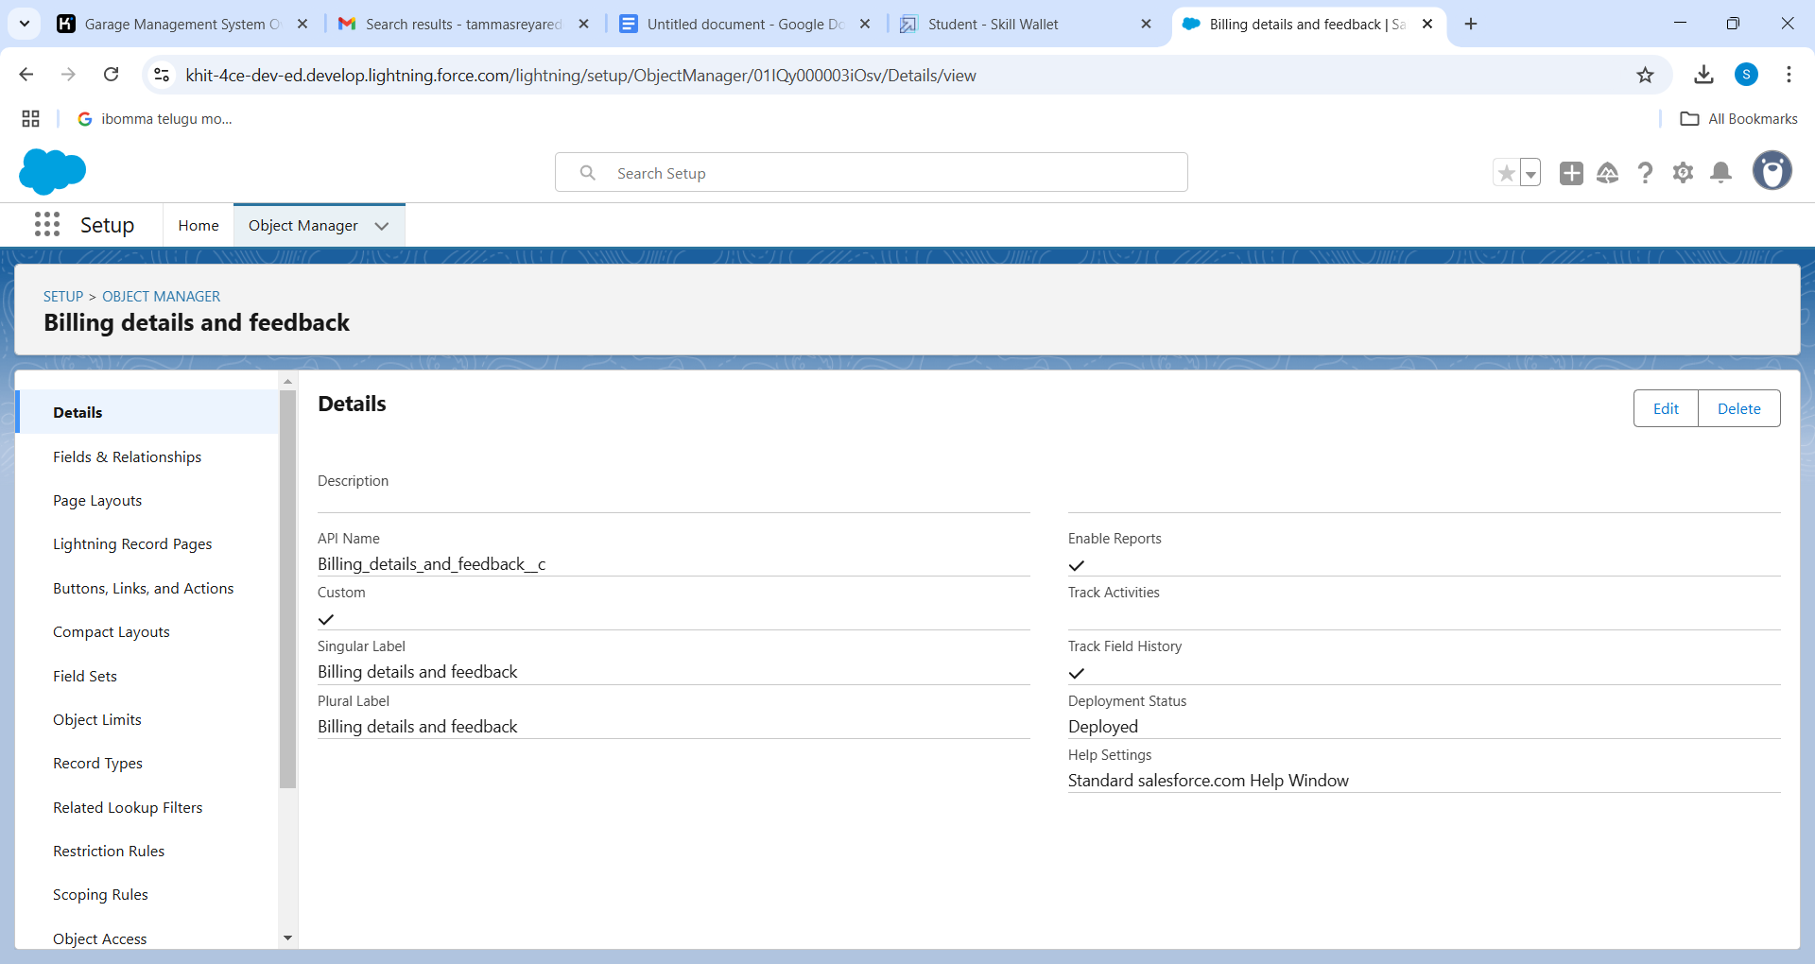

**Milestone 3 :** Tabs

**Creating a Custom Tab**

To create a Tab:(Customer Details)

1. Go to setup page >> type Tabs in Quick Find bar >> click on tabs >> New (under custom object tab)
2. Select Object(Customer Details) >> Select the tab style >> Next (Add to profiles

page) keep it as default >> Next (Add to Custom App)  uncheck the include tab .

1. Make sure that the Append tab to users' existing personal customizations is checked.
2. Click save.

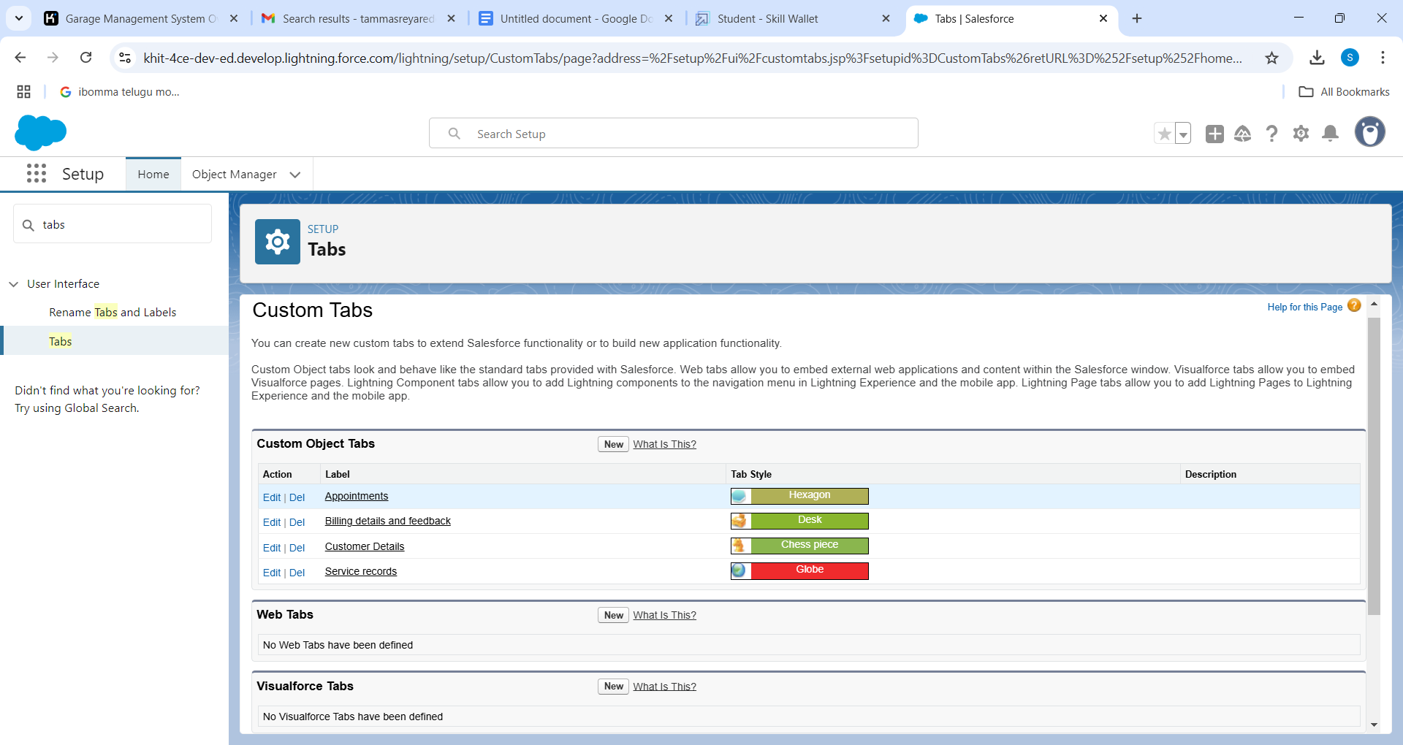

**Creating Remaining Tabs**

1. Now create the Tabs for the remaining Objects, they are “ Appointments, Service records,Billing details and feedback”.
2. Follow the same steps as mentioned in Activity -1.

**Milestone 4 :** The Lightning App

To create a lightning app page:

1. Go to setup page >> search “app manager” in quick find >> select “app manager” >> click on New lightning App.
2. Fill the app name in app details as Garage Management Application >> Next  >>  (App option page) keep it as default  >>  Next  >>  (Utility Items) keep it as default >> Next.
3. To Add Navigation Items:
4. Select the items (Customer Details,Appointments, Service records, Billing details and feedback, Reports and Dashboards) from the search bar and move it using the arrow button  >>  Next.
5. To Add User Profiles.

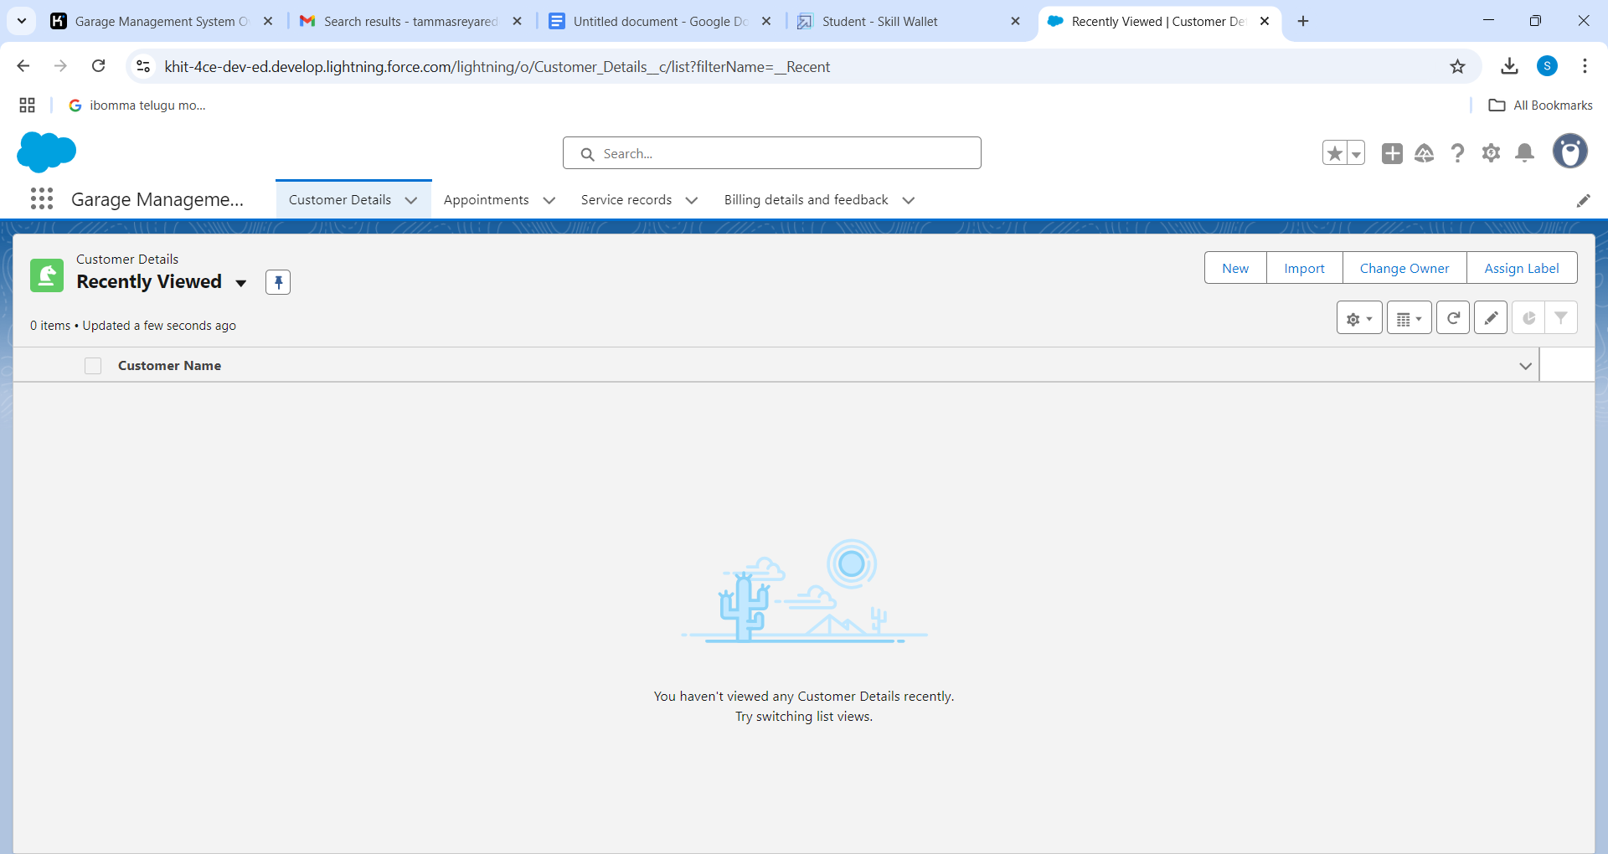

**Milestone 5 :** Fields

**Creation of fields for the Customer Details object**

To create fields in an object:

1. Go to setup >> click on Object Manager >> type object name(Customer Details) in search bar >> click on the object.
2. Now click on “Fields & Relationships” >> New
3. Select Data Type as a “Phone”
4. Click on next.
5. Fill the Above as following:

* Field Label: Phone number.
* Field Name : gets auto generated.
* Click on Next >> Next >> Save and new.

Note: Follow the above steps for the remaining field for the same object.

* To create another fields in an object:

1. Go to setup >> click on Object Manager >> type object name(Customer Details) in search bar >> click on the object.
2. Now click on “Fields & Relationships” >> New
3. Select Data type as a “Email” and Click on Next
4. Fill the Above as following:

* Field Label : Gmail
* Field Name : gets auto generated
* Click on Next  >> Next  >> Save and new.

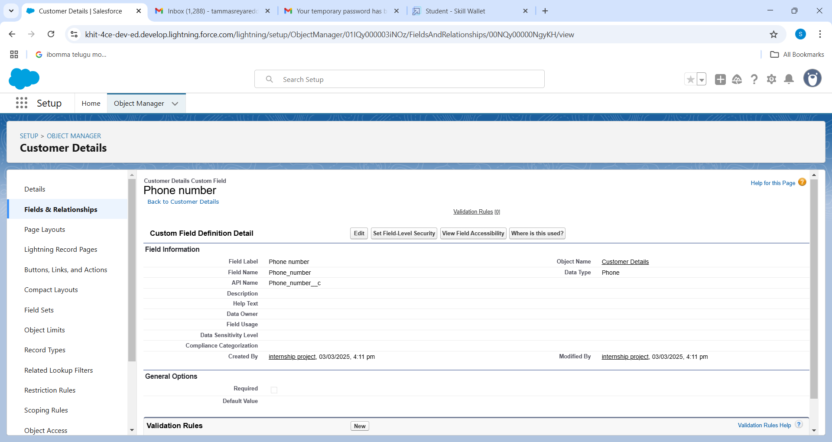

**Creation of Lookup Field on Appointment Object :**

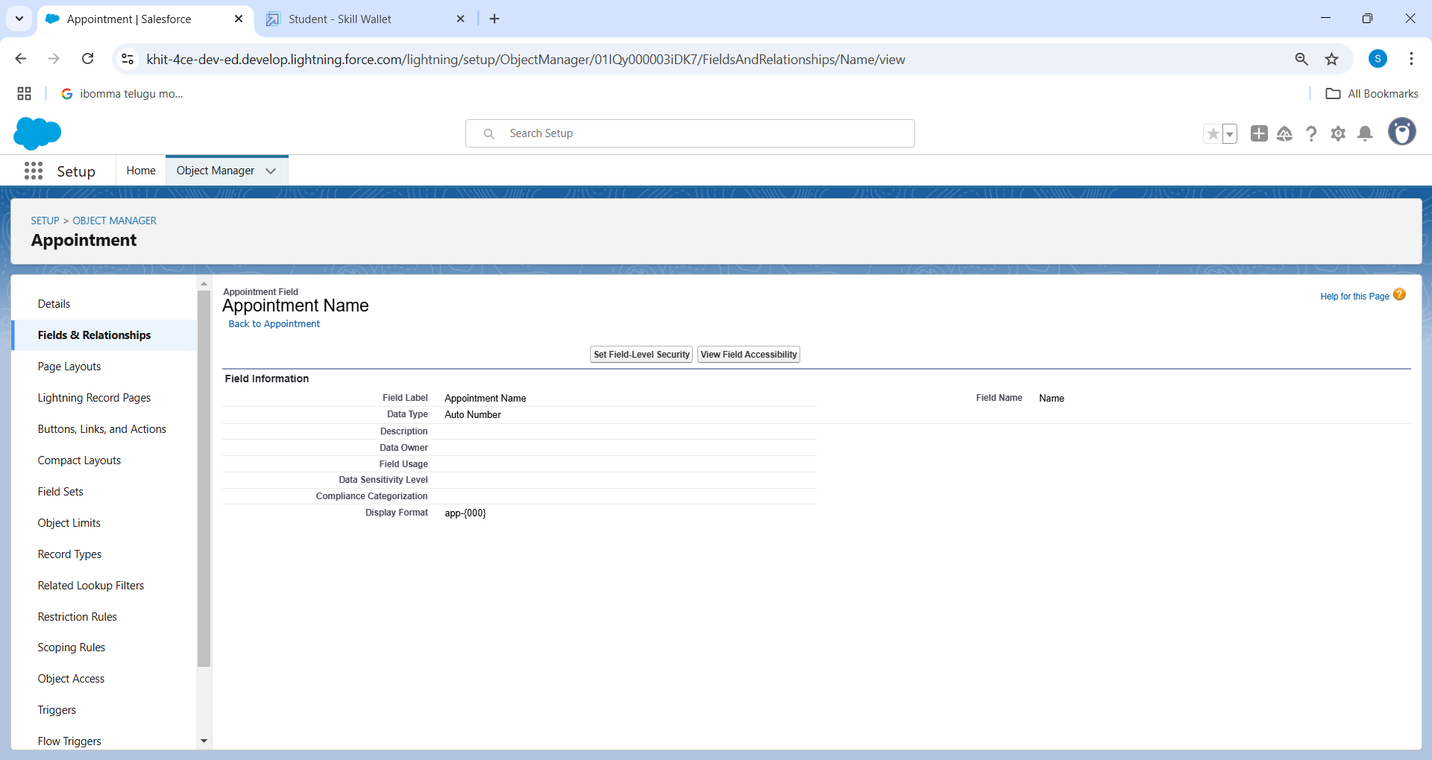

**Creation of Checkbox Field  on Appointment Object :**

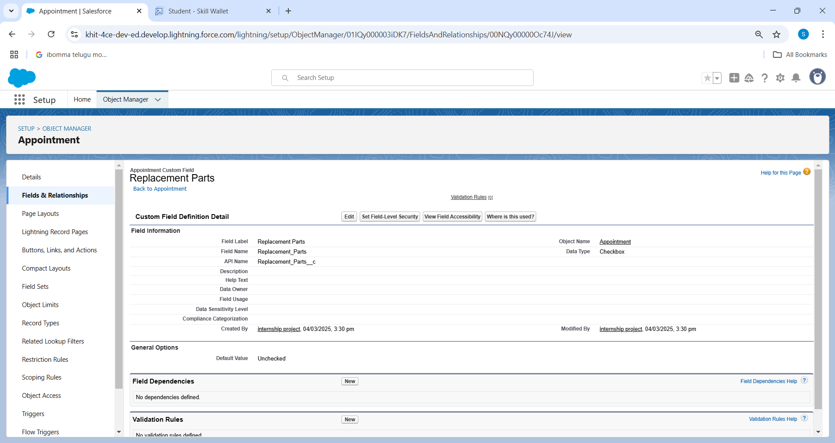

**Creation of Date Field on Appointment Object :**

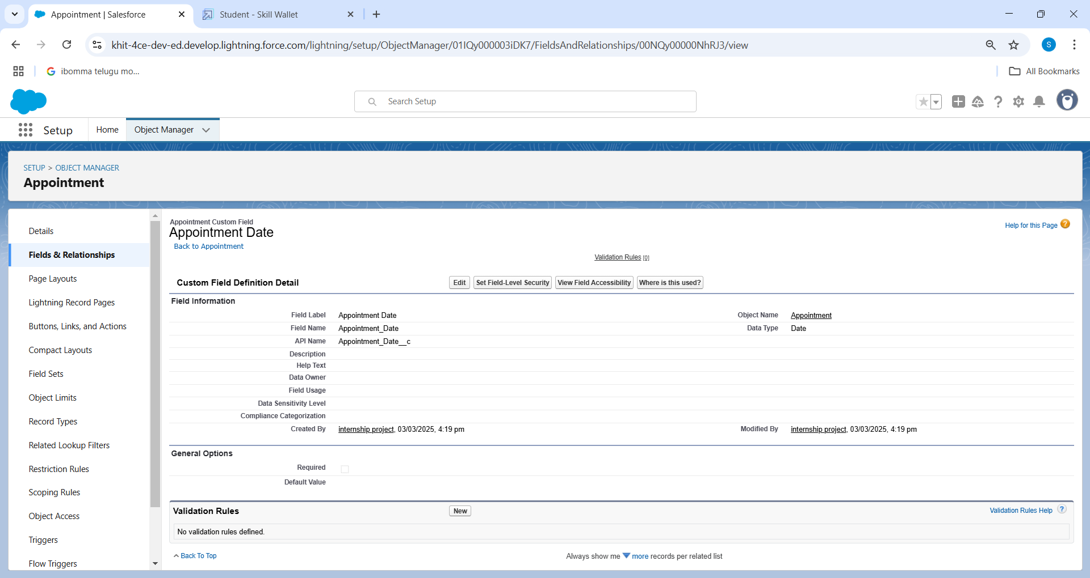

**Creation of Currency Field on Appointment Object :**

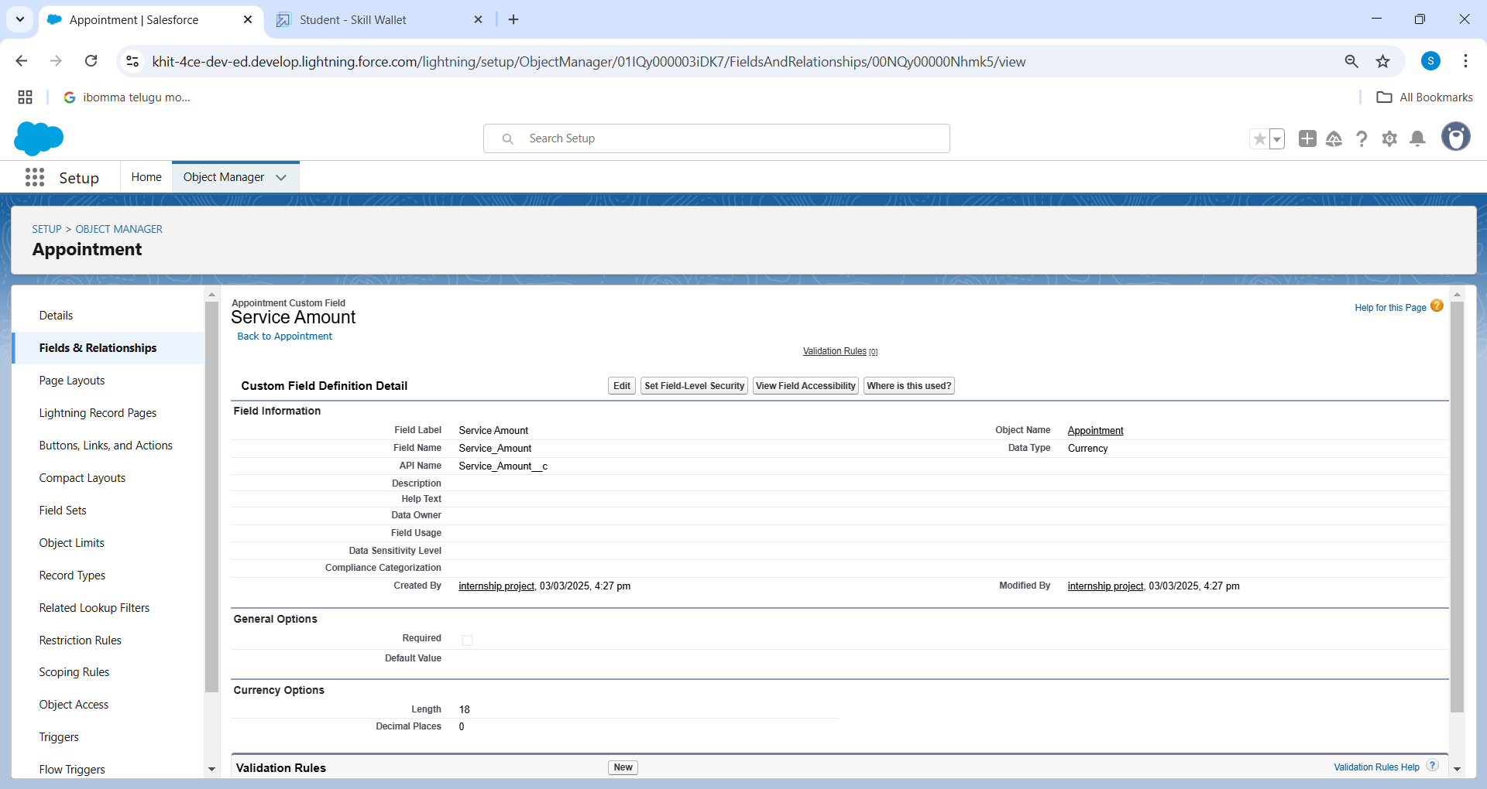

**Creation of Text Fields :**

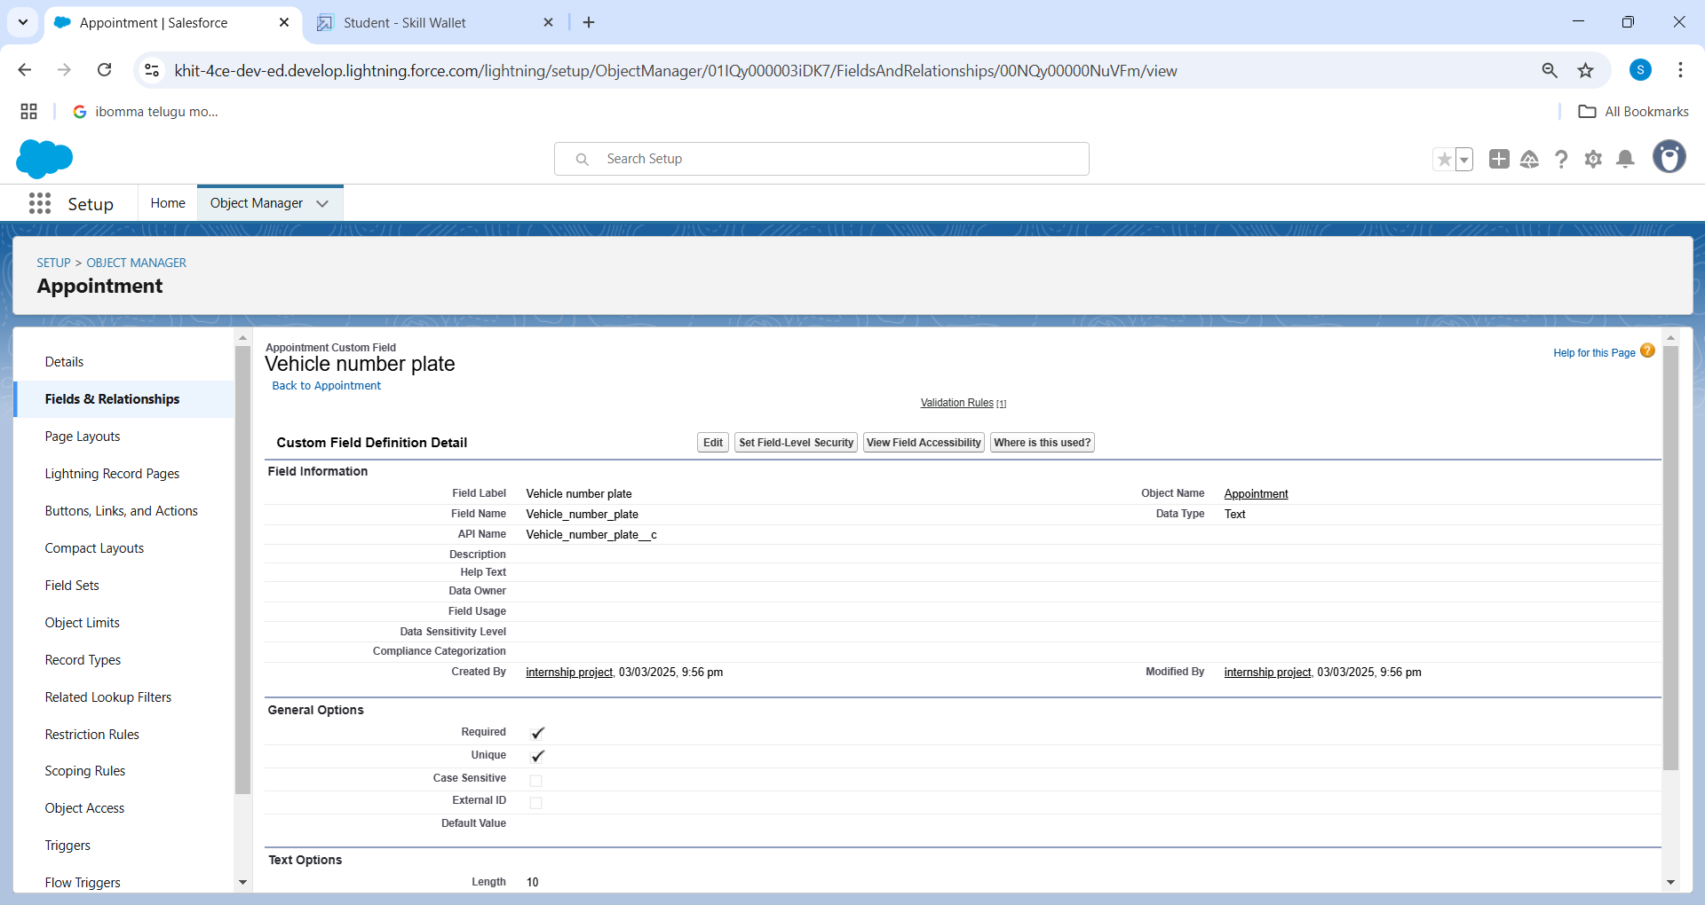

**Creation of Picklist Fields :**

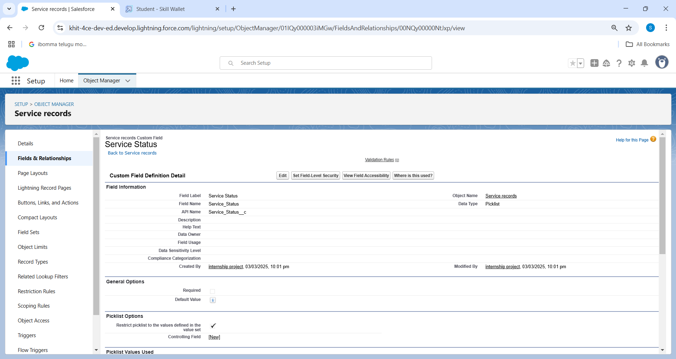

**Creating Formula Field in Service records Object :**

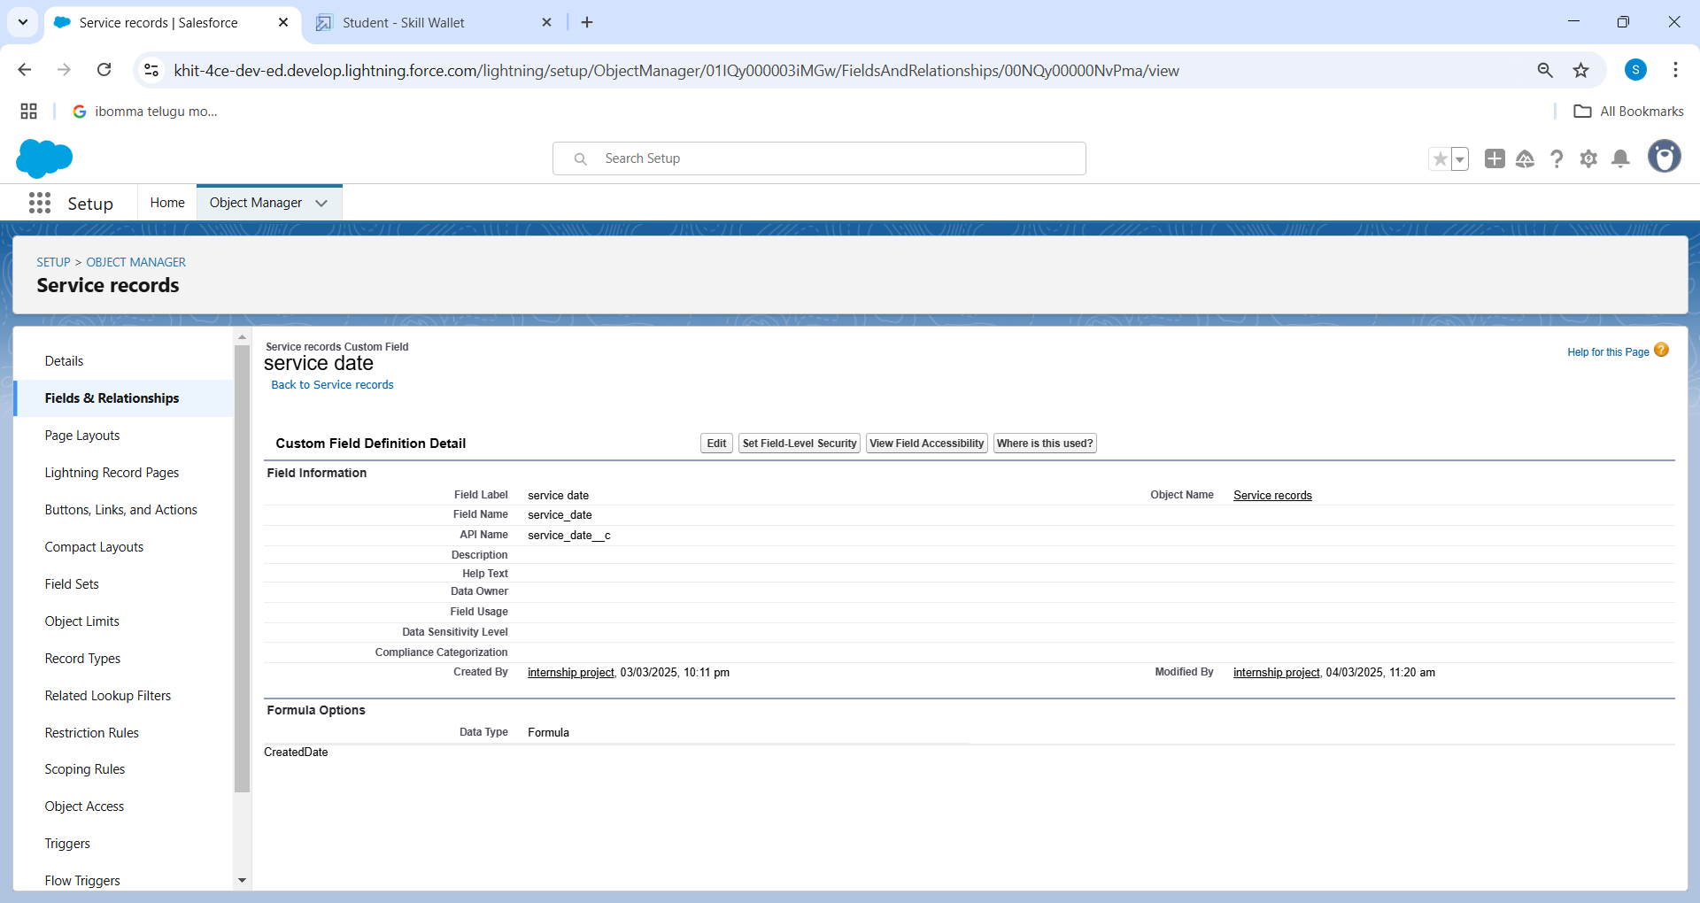

**Milestone 6 :** Validation rule

**To create a validation rule to an Appointment Object**

1. Go to the setup page >>  click on object manager  >>  From drop down click edit for  Appointment object.
2. Click on the validation rule  >> click New.
3. Enter the Rule name as “ Vehicle ”.
4. Insert the Error Condition Formula as : -
5. NOT(REGEX( Vehicle_number_plate__c , "[A-Z]{2}[0-9]{2}[A-Z]{2}[0-9]{4}"))
6. Enter the Error Message as “Please enter vaild number ”, select the Error location as Field and select the field as “Vehicle number plate”, and click Save.

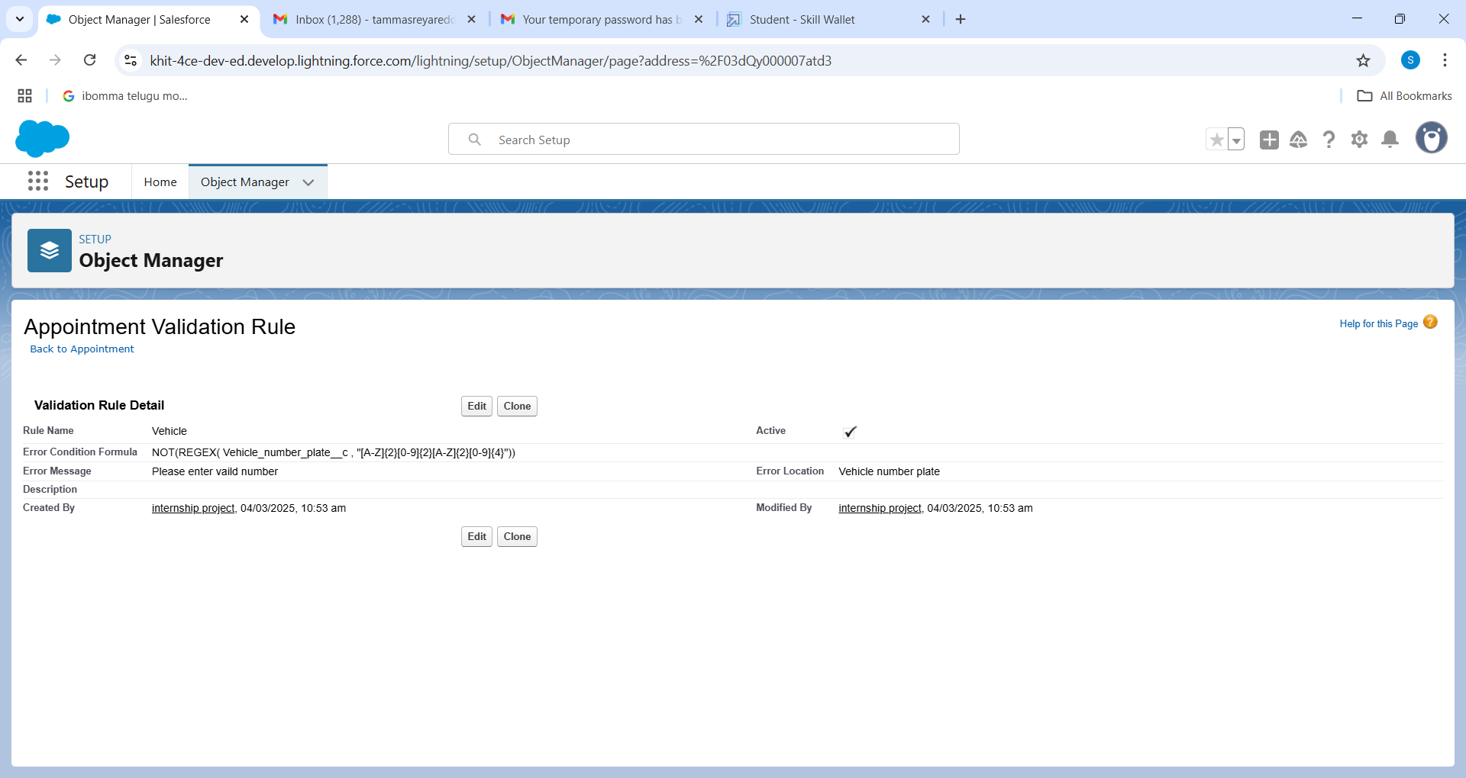

**To create a validation rule to an Billing details and feedback Object :**

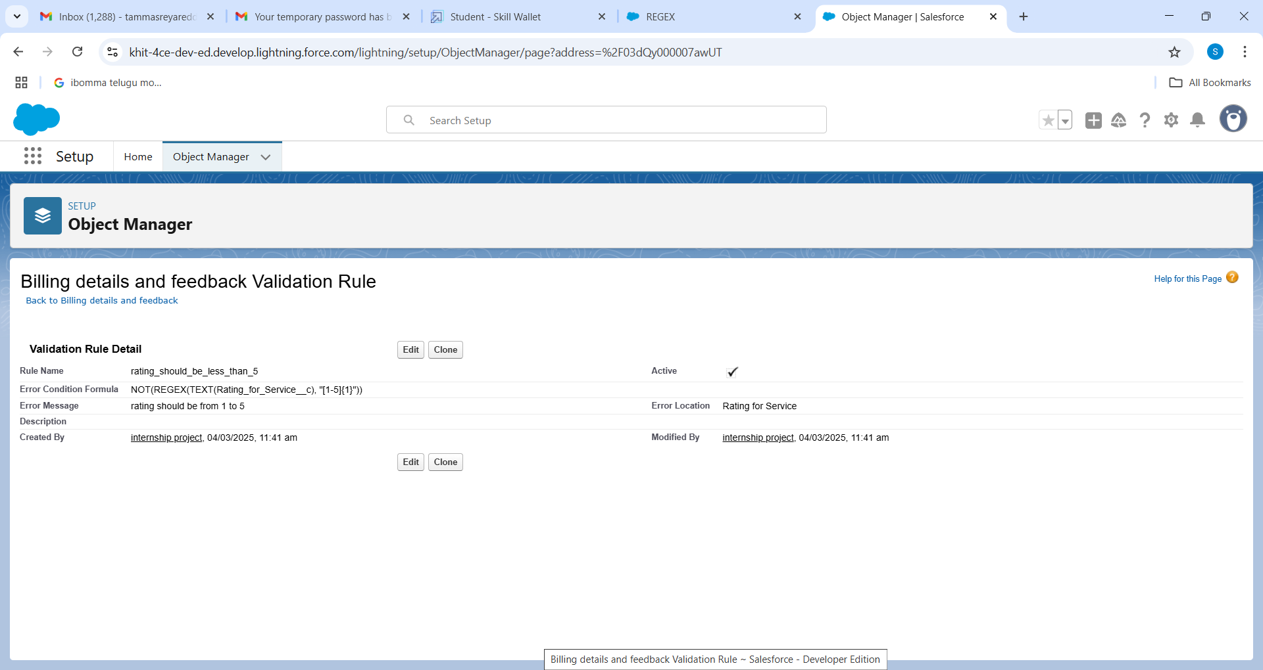

**Milestone 7 :** Duplicate rule

**To create a matching rule to an Customer details Object**

1. Go to quick find box in setup and search for matching Rule.
2. Click on matching rule >> click on New Rule.
3. Select the object as Customer details and click Next.
4. Give the Rule name : Matching customer details
5. Unique name : is auto populated
6. Define the matching criteria as
7. Field                                               Matching Method
8. Gmail                                                       Exact
9. Phone Number                                         Exact
10. Click save.
11. After Saving Click on Activate

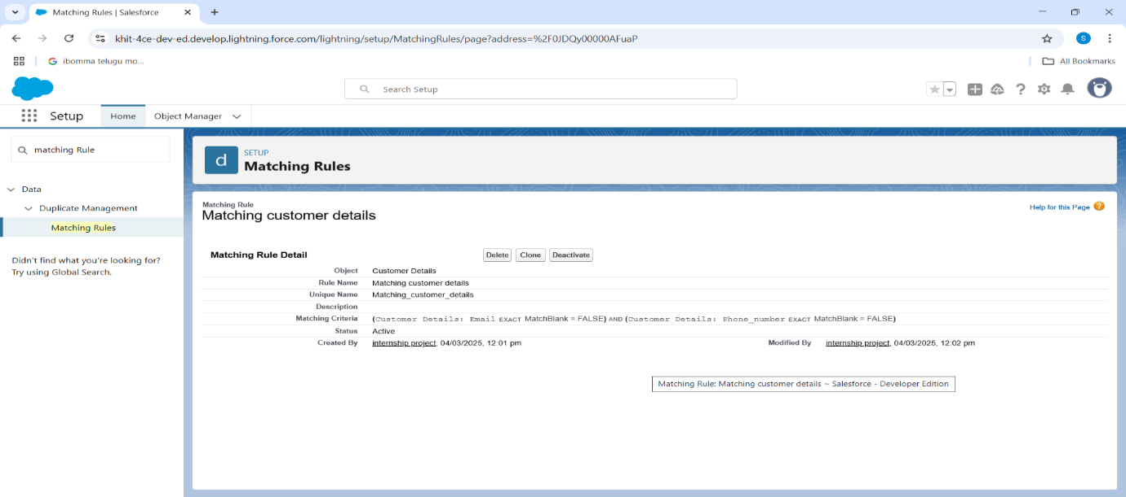

**To create a Duplicate rule to an Customer details Object :**

1. Go to quick find box in setup and search for Duplicate rules.
2. Click on Duplicate rule >>  click on New Rule  >>  select customer details object.
3. Give the Rule name as : Customer Detail duplicate
4. Scroll a little in Matching rule section
5. Select the matching rule : Matching customer details
6. And Click on save.
7. After saving the Duplicate Rule, Click on Activate.

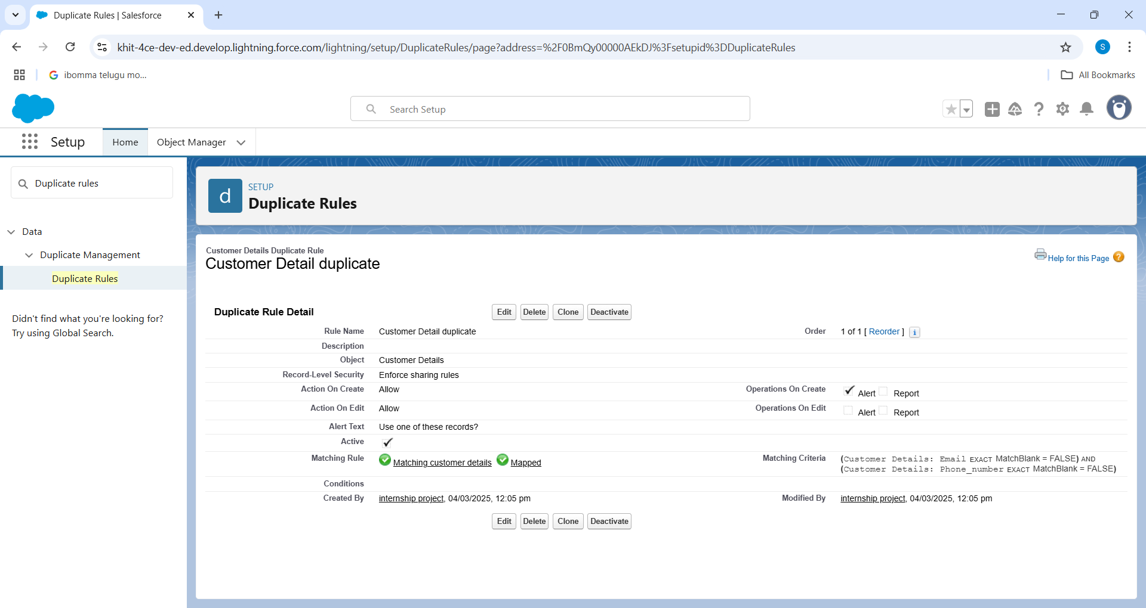

**Milestone 8 :** Profiles

**Manager Profile**

To create a new profile:

1. Go to setup >>  type profiles in quick find box  >>  click on profiles  >>  clone the desired profile (Standard User)  >>  enter profile name (Manager)  >>  Save.
2. While still on the profile page, then click Edit.
3. Select the Custom App settings as default for the Garage management.
4. Scroll down to Custom Object Permissions and Give access permissions for Appointments,Billing details and feedback , service records and customer details objects as mentioned in the below diagram.
5. Changing the session times out after should be “ 8 hours of inactivity”.
6. Change the password policies as mentioned :
7. User passwords expire in should be “ never expires ”.
8. Minimum password length should be “ 8 ”, and click save.

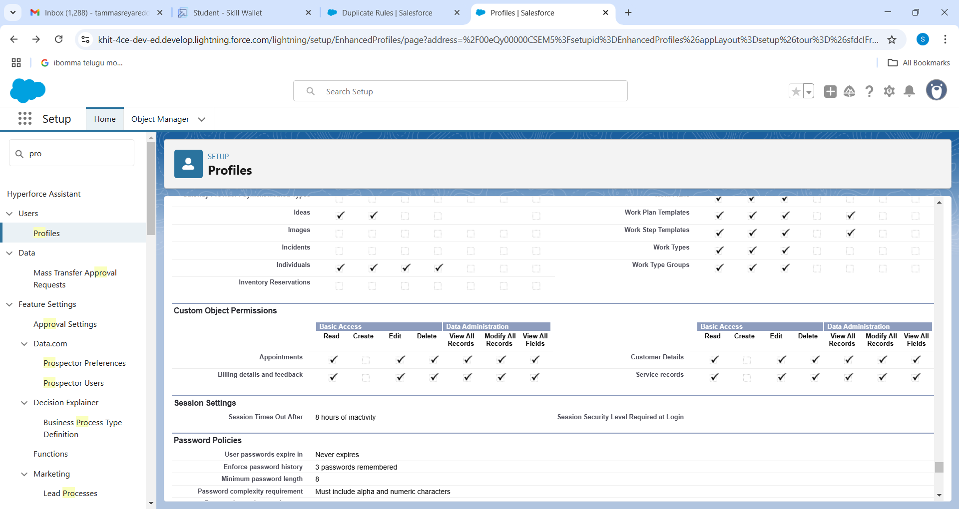

**Sales person Profile**

1. Go to setup >> type profiles in quick find box  >>  click on profiles  >>  clone the desired profile (Salesforce Platform User) >>  enter profile name (sales person)  >>  Save.
2. While still on the profile page, then click Edit.
3. Select the Custom App settings as default for the GArage management.
4. Scroll down to Custom Object Permissions and Give access permissions for Appointments,Billing details and feedback , service records and customer details objects as mentioned in the below diagram.
5. And click save

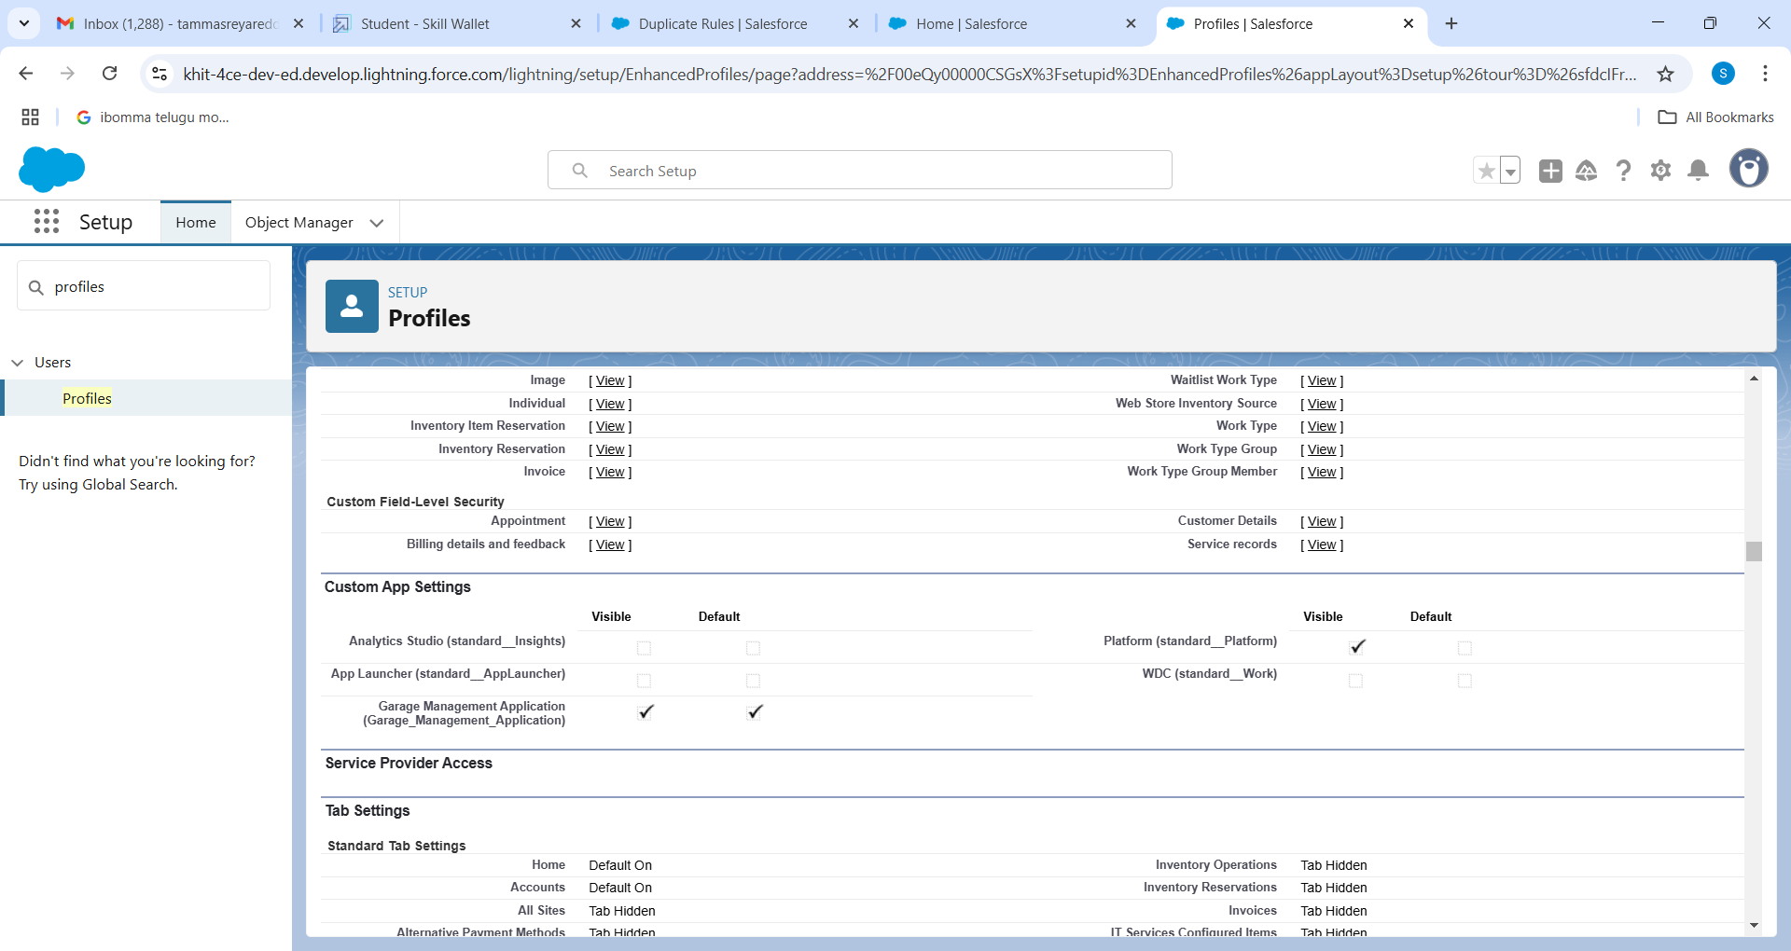

**Milestone 9 :** Role & Role Hierarchy

**Creating Manager Role:**

1. Go to quick find  >>  Search for Roles  >>  click on set up roles.

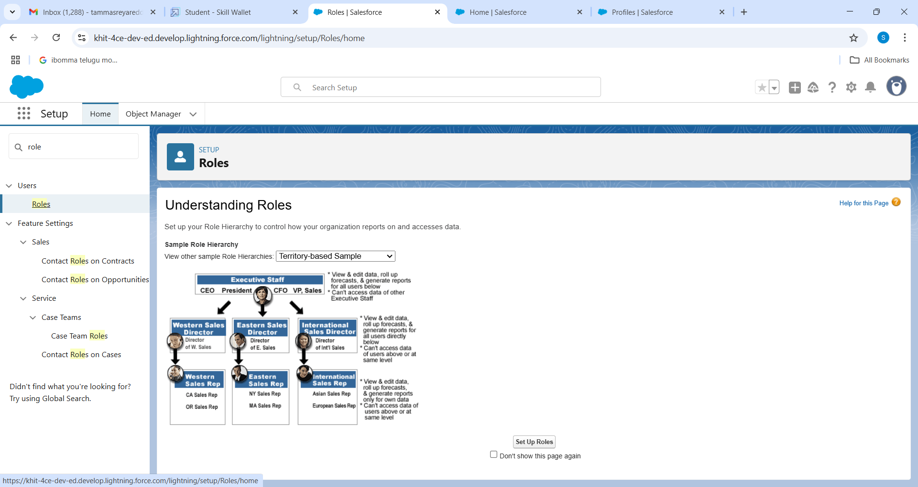

1. Click on Expand All and click on add role under whom this role works.

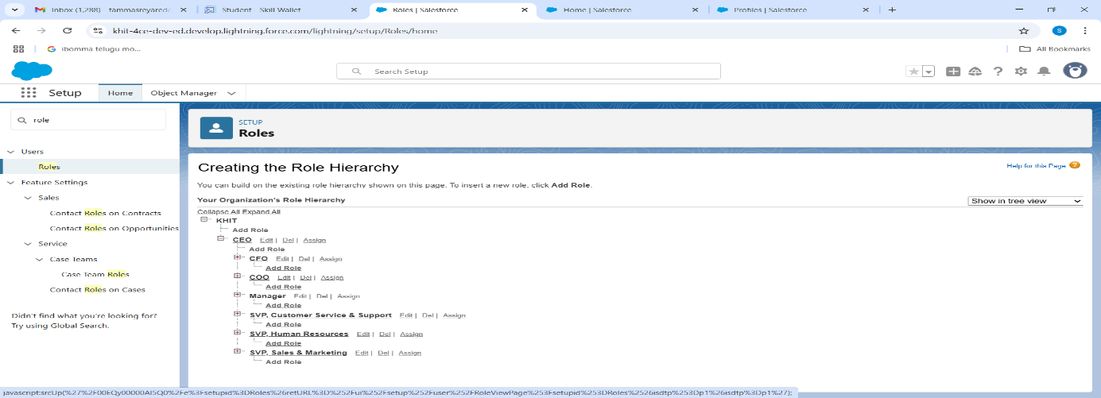

1. Give Label as “Manager” and Role name gets auto populated. Then click on Save.

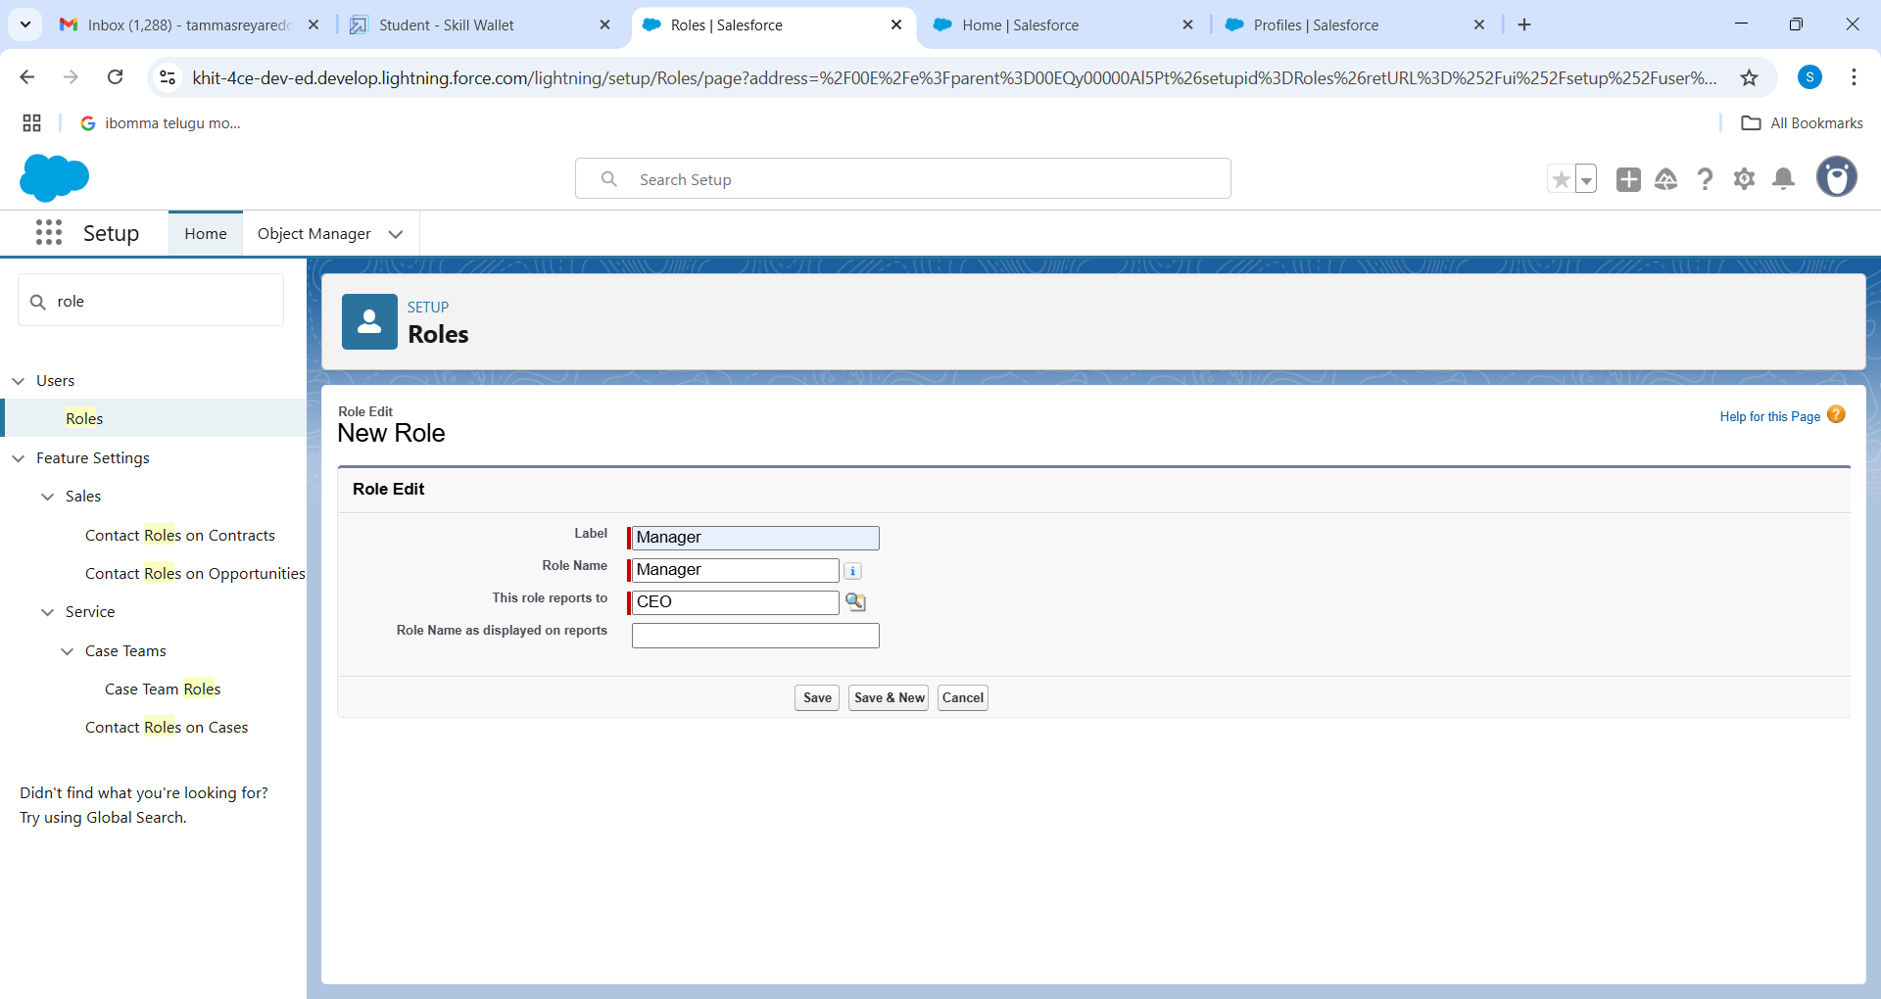

**Creating another roles**

1. Creating another two roles under manager
2. Go to quick find  >>  Search for Roles  >>  click on set up roles.
3. Click plus on CEO role, and click add role under manager.
4. Give Label as “sales person” and Role name gets auto populated. Then click on Save.

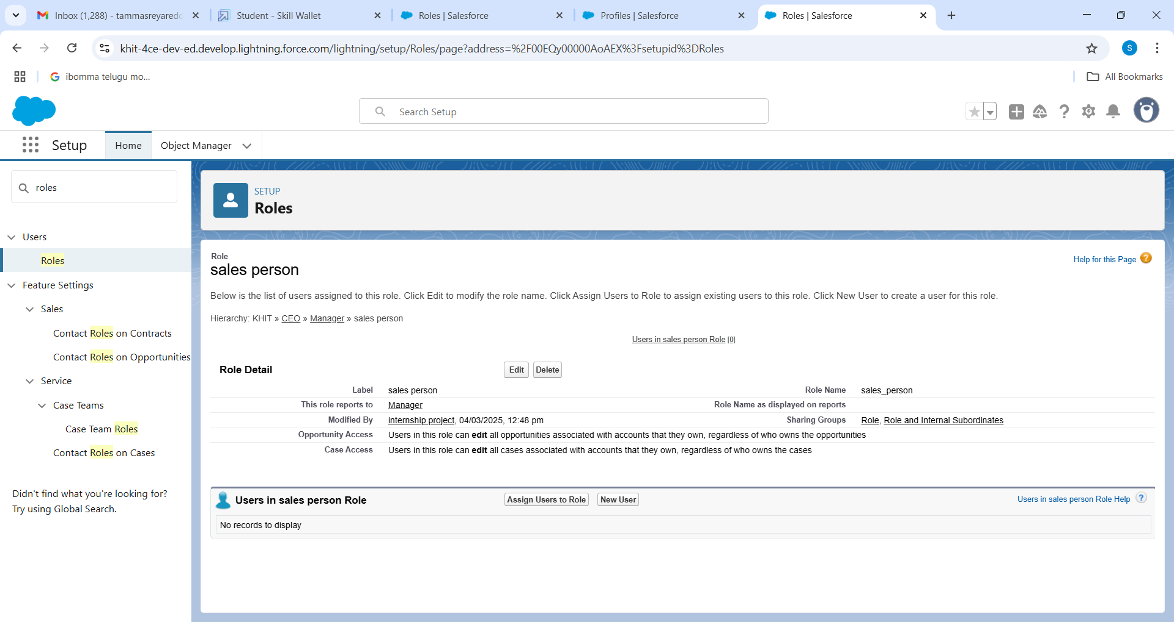

**Milestone 10 :** Users

**Create User**

1. Go to setup  >>  type users in quick find box  >>  select users  >> click New user.
2. Fill in the fields
3. First Name : Niklaus
4. Last Name : Mikaelson
5. Alias : Give a Alias Name
6. Email id : Give your Personal Email id
7. Username : Username should be in this form: text@text.text
8. Nick Name : Give a Nickname
9. Role : Manager
10. User licence : Salesforce
11. Profiles : Manager
12. Save

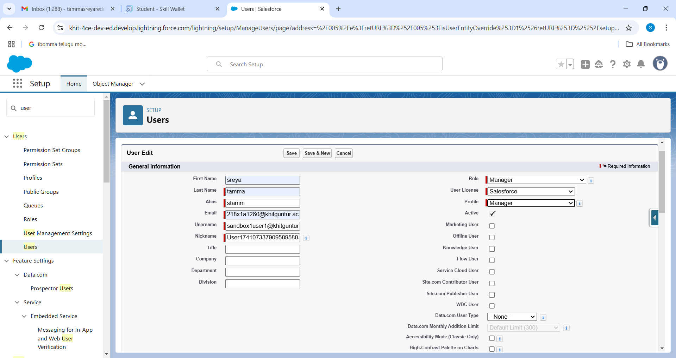

**creating another users**

1. Repeat the steps and create another user using
   1. Role                  : sales person
   2. User licence      : Salesforce Platform
   3. Profile               : sales person

Note : create atleast 3 users with these permissions.

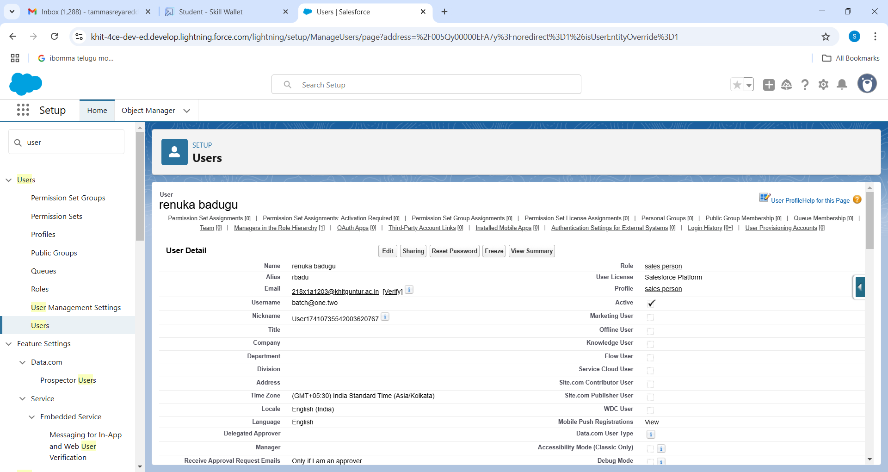

**Milestone 11 :** Public groups

**Creating New Public Group**

1. Go to setup  >>  type users in quick find box  >>  select public groups >> click New.
2. Give the Label as “sales team”.
3. Group name is autopopulated.

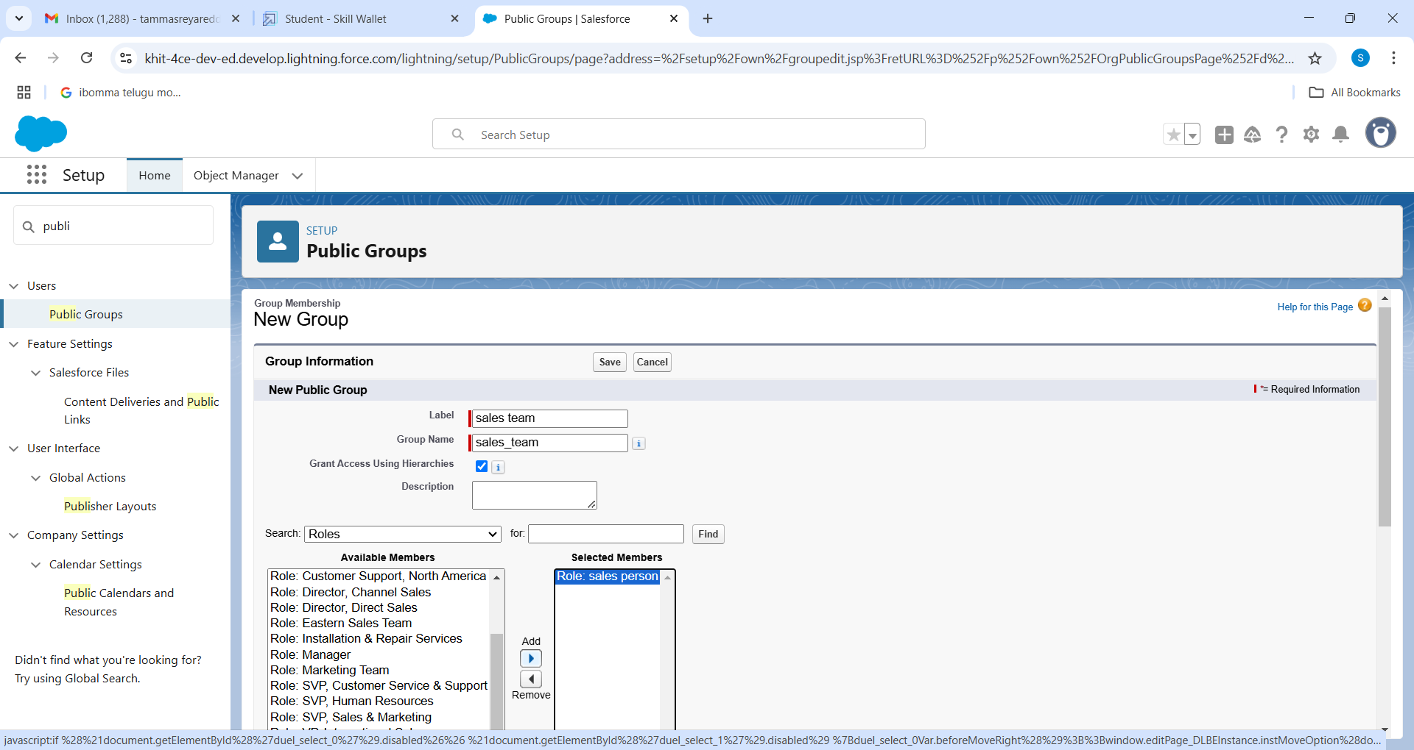

1. Search for Roles.
2. In Available Members select Sales person and click on add it will be moved to selected member.
3. Click on save.

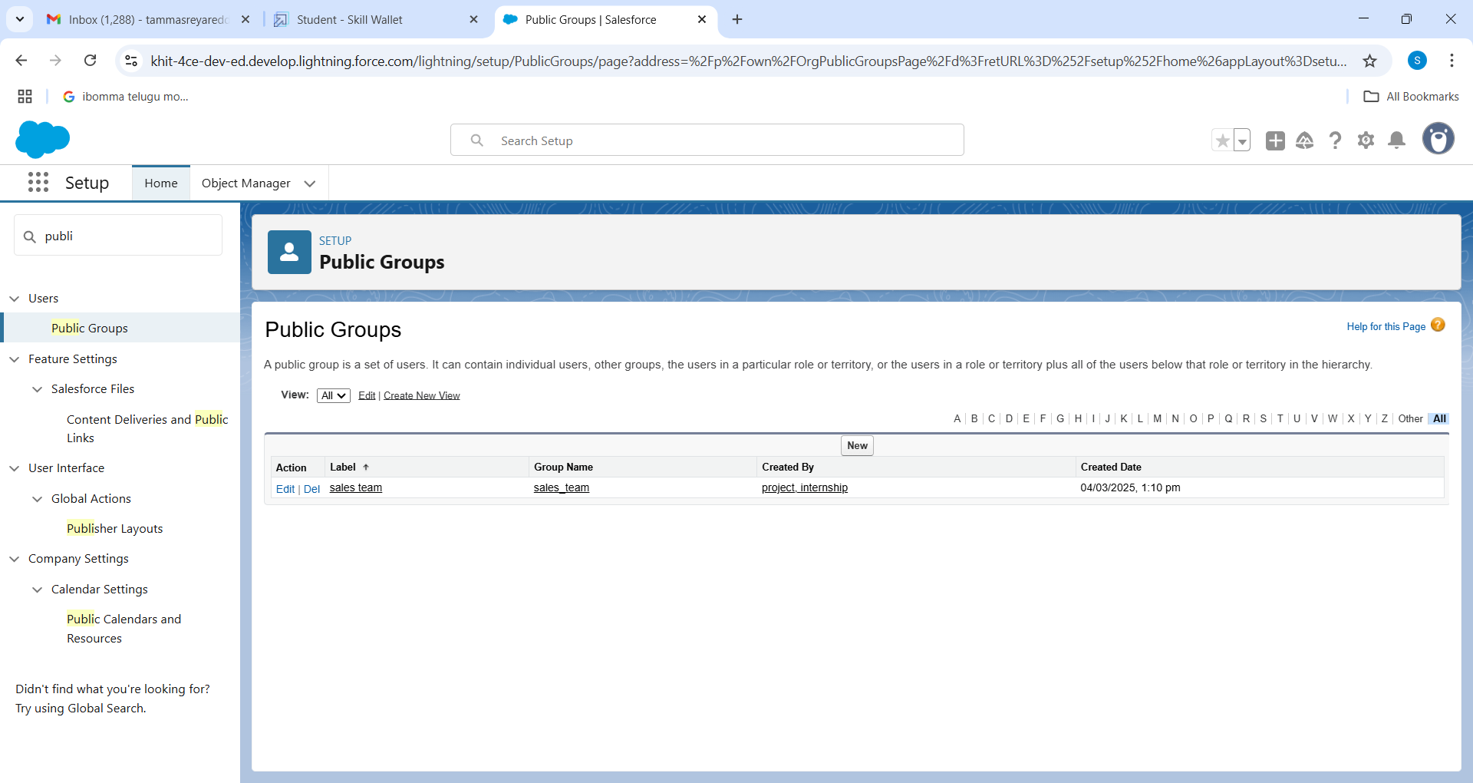

**Milestone 12 :** Sharing Setting

**Creating Sharing settings**

1. Go to setup  >>  type users in quick find box  >>  select Sharing Settings >>  click Edit.
2. Change the OWD setting of the Service records Object to private as shown in fig.
3. Click on save and refresh.
4. Scroll down a bit, Click  new  on Service records sharing Rules.
5. Give the Label name as “ Sharing setting”
6. Rule name is auto populated.
7. In step 3 : Select which records to be shared, members of “ Roles ” >> “ Sales person”
8. In step 4: share with, select “ Roles ” >> “ Manager ”
9. In step 5 : Change the access level to “ Read / write ”.
10. Click on save.

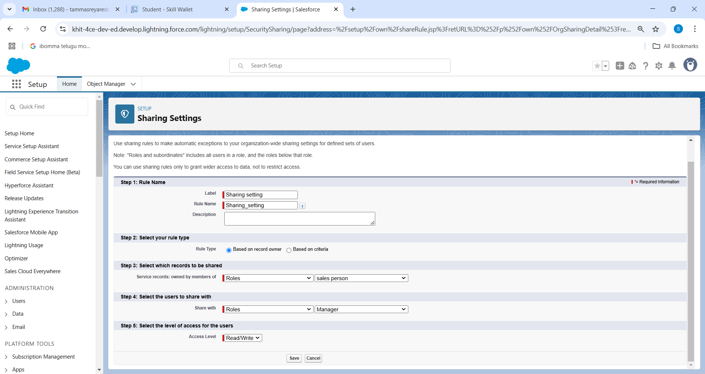

**Milestone 13 :** Flows

**Create a Flow**

1. Go to setup  >>  type Flow in quick find box  >>  Click on the Flow and Select the New Flow.
2. Select the Record-triggered flow and Click on Create.
3. Select the Object as “Billing details and feedback”in the Drop down list.
4. Select the Trigger Flow when: “A record is Created or Updated”.
5. Select the Optimize the flow for: “Actions and Related Records” and Click on Done.
6. Under the Record-triggered Flow Click on “+” Symbol and In the Drop down List select the “Update records Element”.
7. Give the Label Name : Amount Update
8. Api name : is auto populated
9. Give the Label Name : Amount Update
10. Api name : is auto populated
11. Click on the New Resource, And select Variable.
12. Select the resource type as text template.
13. Enter the API name as “ alert”.
14. Change the view as Rich Text ? View to Plain Text.
15. In body field  paste the syntax that given below.
16. Dear {!$Record.Service_records__r.Appointment__r.Customer_Name__r.Name},
17. Before creating another Element. Create a New Resource form Toolbox form top left.
18. Click on the New Resource, And select Variable
19. Enter the API name as “ alert”
20. Select the resource type as text template
21. Amount paid : {!$Record.Payment_Paid__c}
22. Thank you for Coming .
23. Click done.
24. Now Click on Add Element , select Action.
25. Their action bar will be opened in that search for “ send email ” and click on it.
26. Give the label name as “ Email Alert”
27. API name will be auto populated.
28. Enable the body in set input values for the selected action.
29. Select the text template that created , Body : {!alert}
30. Include recipient address list select the email form the record.
31. RecipientAddressList: {!$Record.Service_records__r.Appointment__r.Customer_Name__r.Gmail__c}
32. Include subject as “ Thank You for Your Payment - Garage Management”.
33. Click done.
34. Click on save. Give the Flow label , Flow Api name will be autopopulated.
35. And click save, and click on activate.

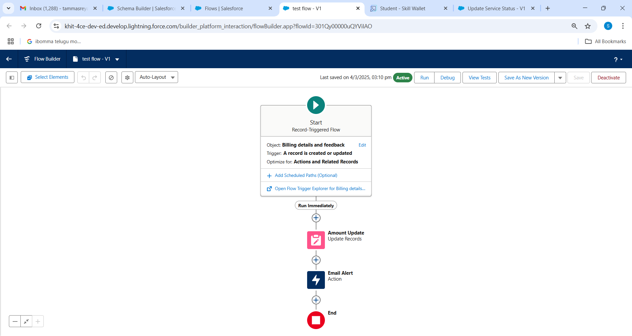

**Create another Flow**

* 1. Go to setup ? type Flow in quick find box ? Click on the Flow and Select the New Flow.
  2. Select the Record-triggered flow and Click on Create.
  3. Select the Object as “ Service records”in the Drop down list.
  4. Select the Trigger Flow when: “A record is Created or Updated”.
  5. Select the Optimise the flow for: “Actions and Related Records” and Click on Done.
  6. Under the Record-triggered Flow Click on “+” Symbol and In the Drop down List select the “Update records Element”.
  7. Set a filter condition : All Conditions are met(AND)
  8. Field : Quality_Check_Status__c
  9. Operator : Equals
  10. Value : True
  11. And Set Field Values for the Billing details and feedback Record
  12. Field  : Service_Status__c
  13. Value  : Completed
  14. Click On Done.
  15. Click on save
  16. Given the Flow label as Update Service Status , Flow Api name will be auto populated.
  17. And click save, and click on activate.

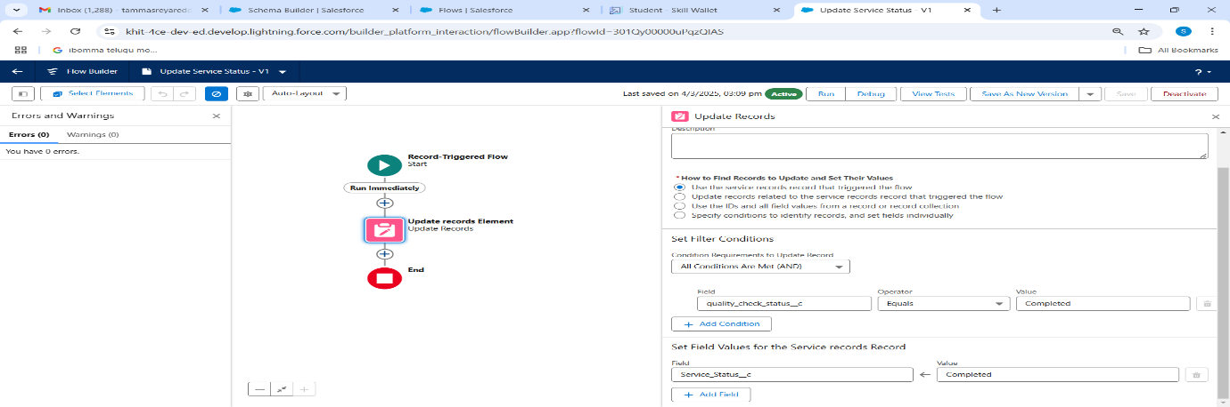

**Milestone 14 :** Apex Trigger

**Apex handler**

UseCase : This use case works for Amount Distribution for each Service the customer selected for there Vehicle.

1. Login to the respective trailhead account and navigate to the gear icon in the top right corner.
2. Click on the Developer console. Now you will see a new console window.
3. In the toolbar, you can see FILE. Click on it and navigate to new and create New apex class.
4. Name the class as “AmountDistributionHandler ”.

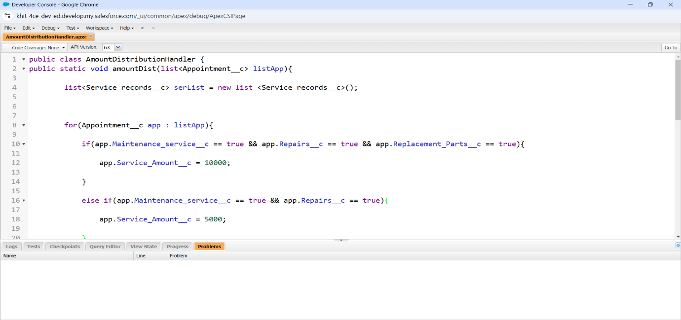

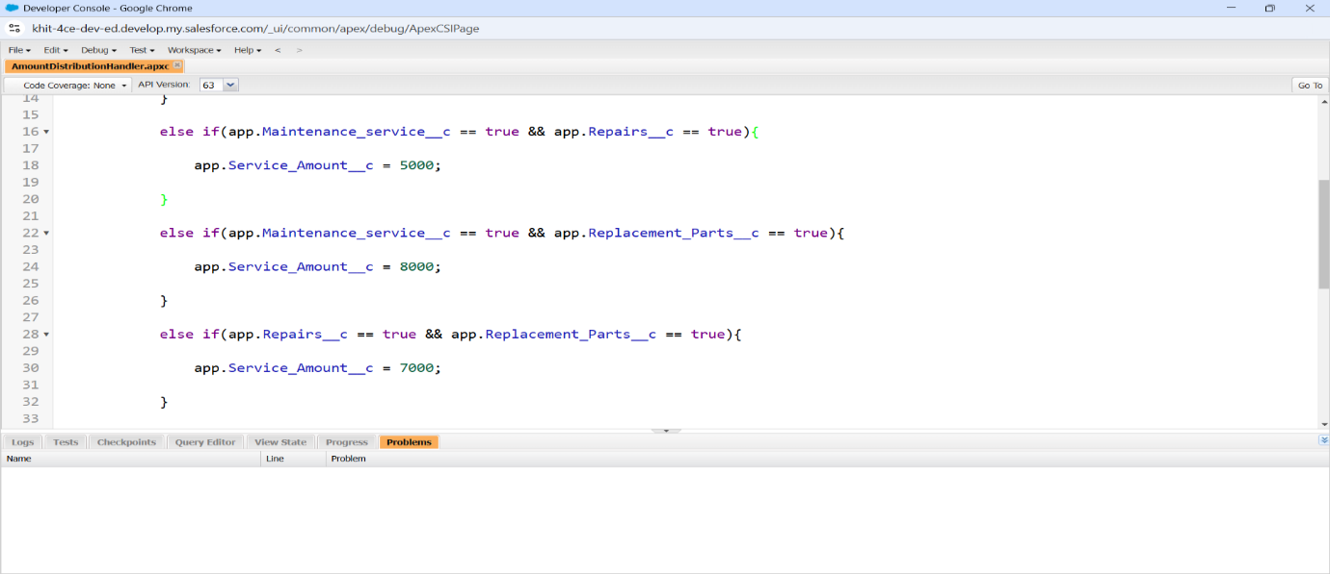

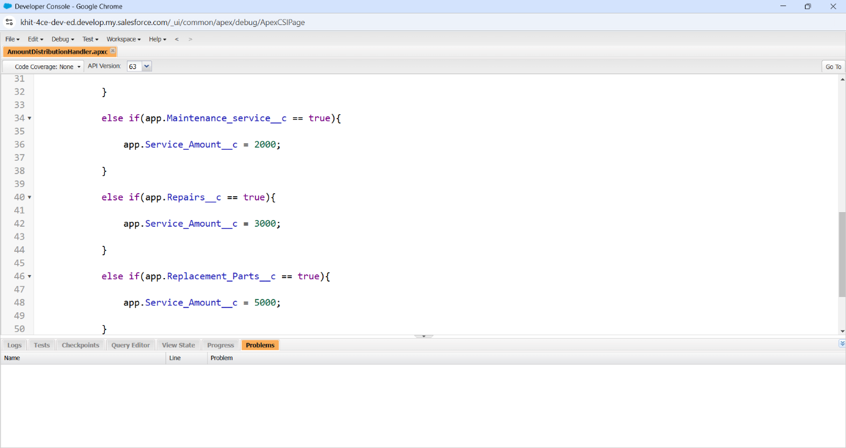

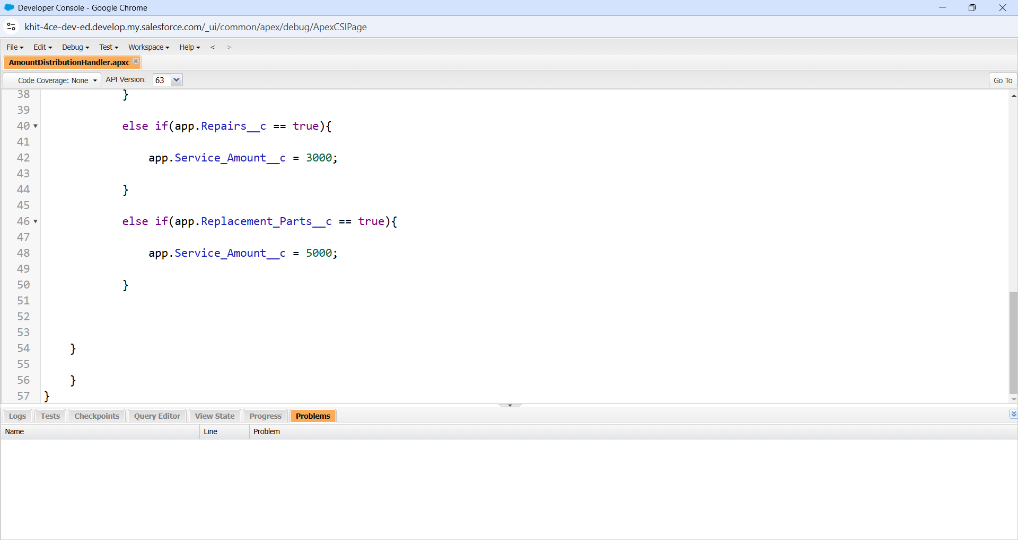

**Trigger Handler** :

How to create a new trigger :

1. While still in the trailhead account, navigate to the gear icon in the top right corner.
2. Click on developer console and you will be navigated to a new console window.
3. Click on File menu in the tool bar, and click on new? Trigger.
4. Enter the trigger name and the object to be triggered.
5. Name  : AmountDistribution
6. sObject : Appointment__c

Syntax For creating trigger :

The syntax for creating trigger is :

Trigger [trigger name] on [object name]( Before/After event)

{

}

In this project , trigger is called whenever the particular records sum exceed the threshold i.e minimum business requirement value. Then the code in the trigger will get executed.

1. Handler for the Appointment Object

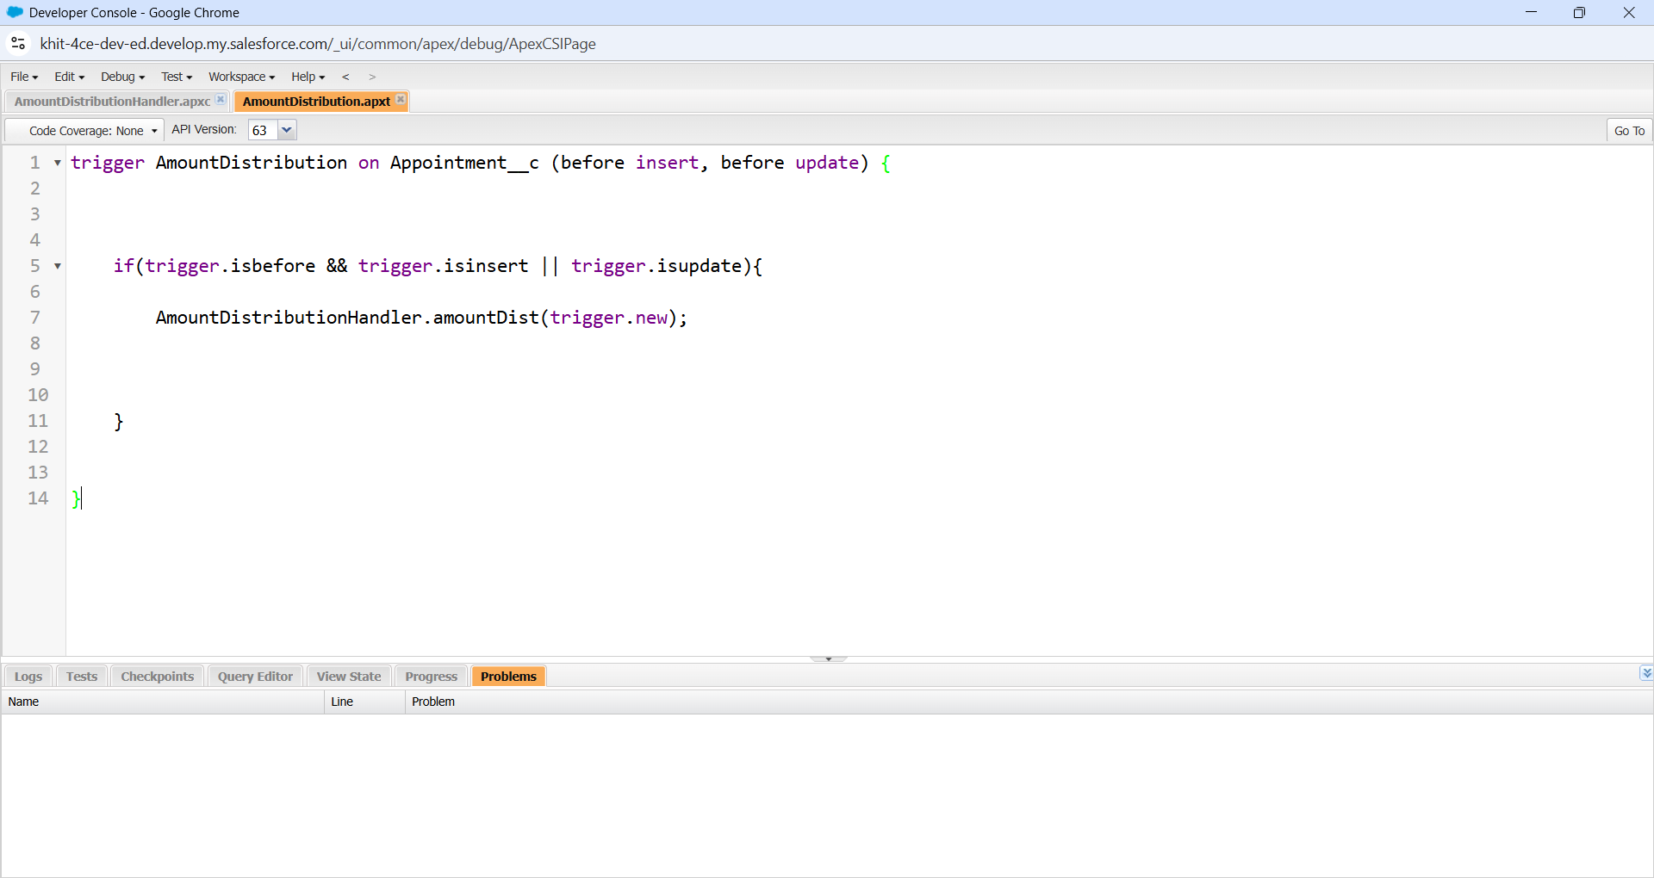

**Milestone 15 :** Reports

**create a report folder** :

1. Click on the app launcher and search for reports.
2. Click on the report tab, click on new folder.
3. Give the Folder label as “Garage Management Folder”, Folder unique name will be auto populated.
4. Click save.

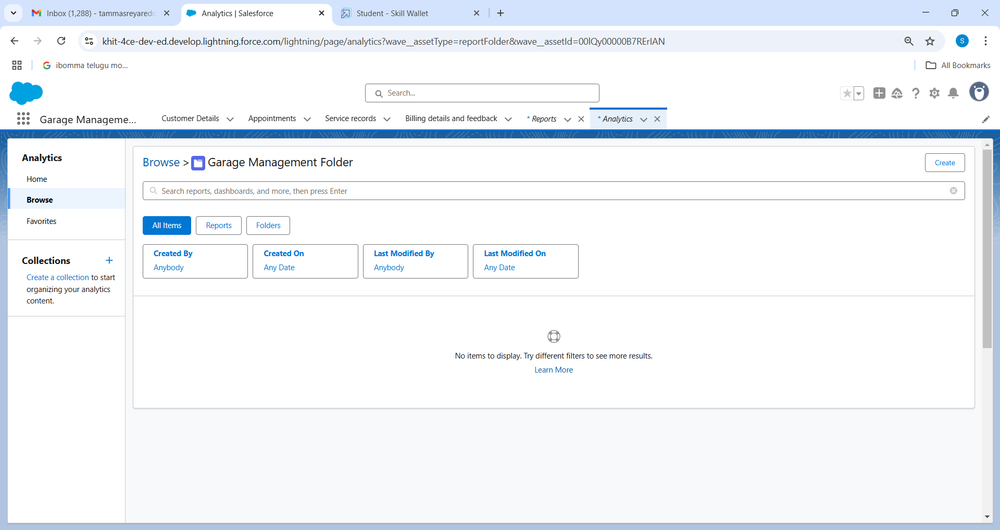

**Sharing a report folder :**

1. Go to the app  >> click on the reports tab.
2. Click on the All folder , click on the Drop down arrow for Garage Management folder, and Click on share.
3. Select the share with as “roles”, in name field search for “manager”, give “view” as access for that role.
4. Then click share, and click on Done.

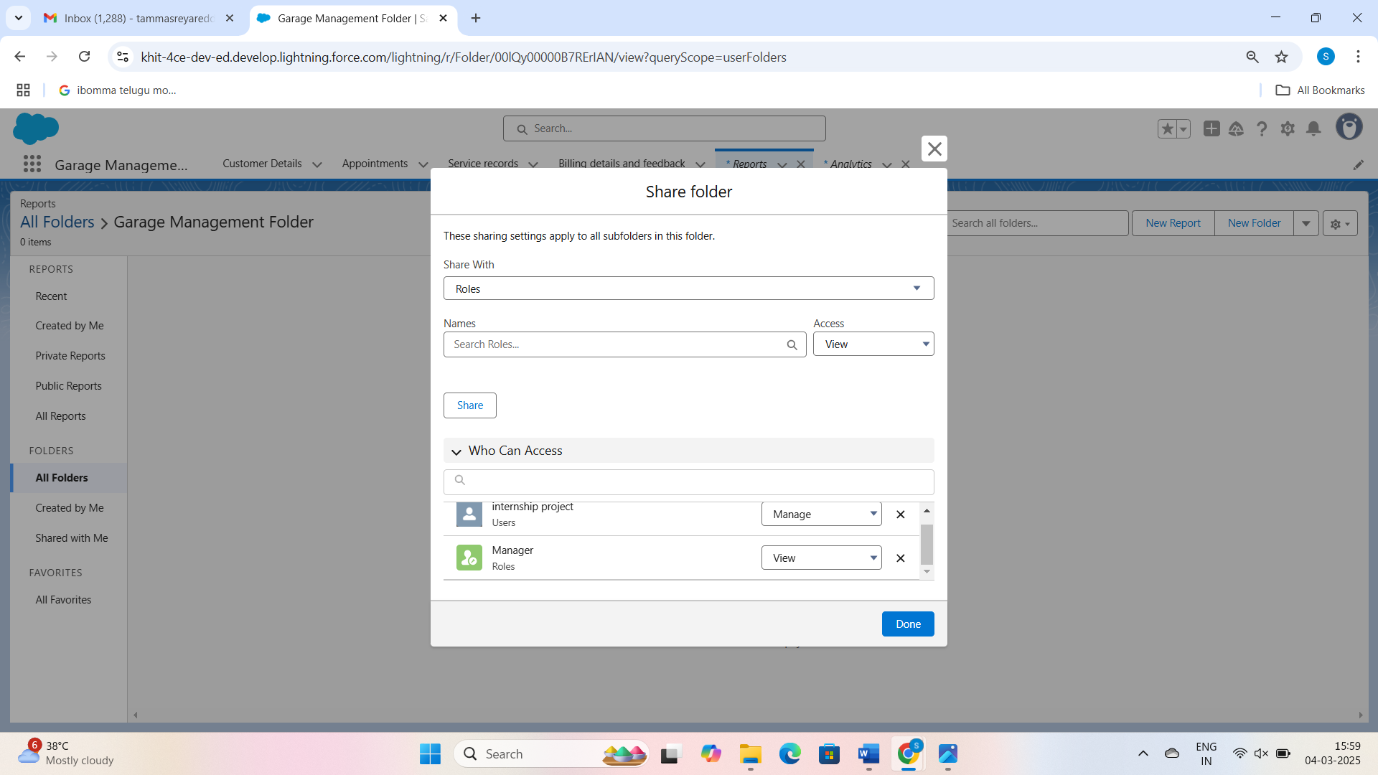

**Create Report Type**

1. Go to setup  >>  type users in quick find box  >>  select Report Type >> click on Continue.
2. Click on new custom report type.
3. Select the Primary object as “ Customer details” .
4. Give the Report type Label as  “ Service information ”
5. Report type Name is autopopulated.
6. Keep the Description as same.
7. Select Store in Category as “ other Reports ”
8. Select the deployment status as “ Depolyed ”, click on Next.
9. now , Click on Related object box.
10. Click on Select Object, choose Appointment Object as shown in fig.
11. Again Click to relate another object.
12. And select the related object as “ service records”.
13. Repeat the process and select the related object as “ Billing details and feedback”.
14. And click on save.

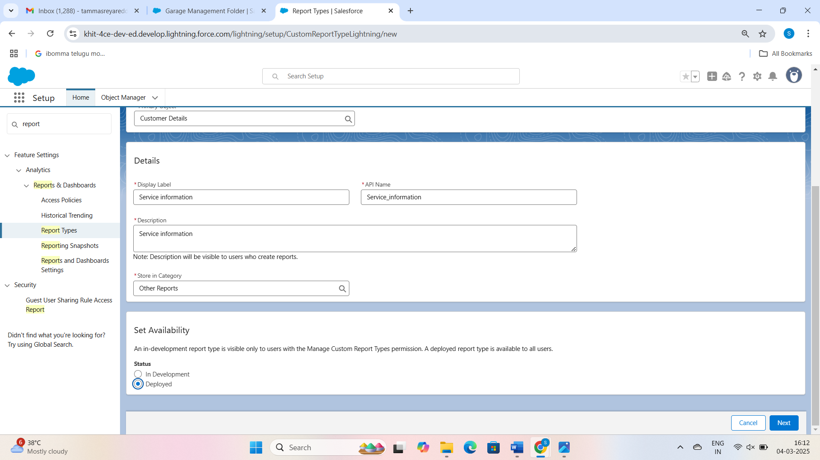

**Create Report**

Note : Before creating report, create latest “10” records in every object.

Try to fill every field in each record for better experience.

1. Go to the app  >>  click on the reports tab
2. Click New Report.
3. Select the Category as other reports, search for Service Information, select that report, click on it. And click on start report.
4. Their outline pane is opened alredy, select the fields that mentioned below in column section.
   1. Customer name
   2. Appointment Date
   3. Service Status
   4. Payment paid
5. Remove the unnecessary fields.
6. Select the fields that mentioned below in GROUP ROWS section.
   1. Rating for Service
7. Select the fields that mentioned below in GROUP ROWS section.
   1. Payment Status
8. Click on Add Chart , Select the Line Chart.
9. Click on save, Give the report Name : New Service information Report
10. Report unique Name is auto populated.
11. Select the folder the created and Click on save.

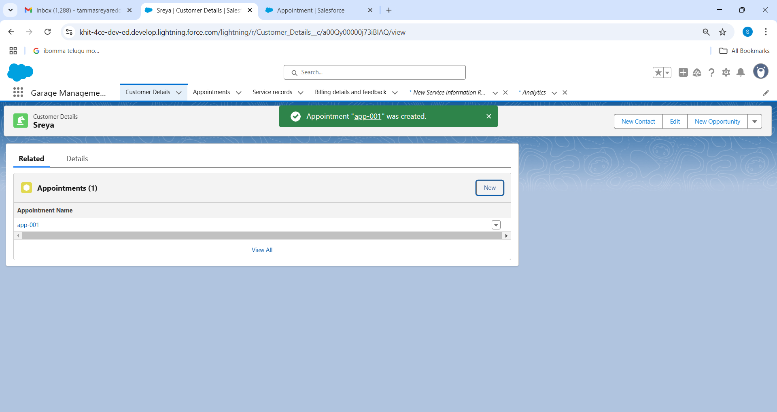

**Milestone 16** : Dashboard

**Create Dashboard Folder :**

1. Click on the app launcher and search for dashboard.
2. Click on dashboard tab.
3. Click new folder, give the folder label as “ Service Rating dashboard”.
4. Folder unique name will be auto populated.
5. Click save.
6. Follow the same steps, from Reports Milestone and Activity 2, and provide the sharing settings for the folder that was just created.

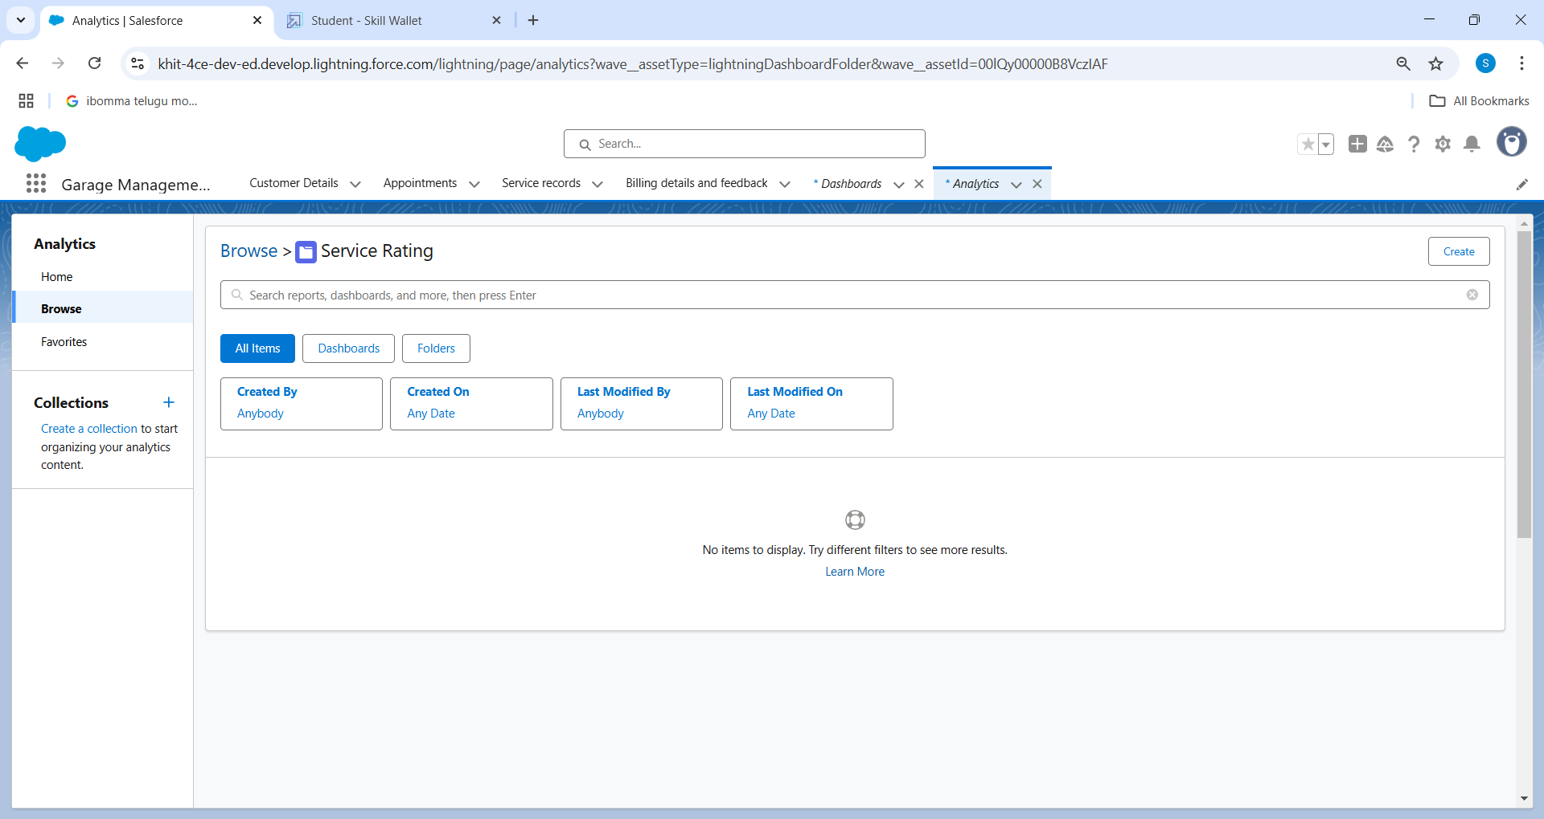

**Create Dashboard**

1. Go to the app >>  click on the Dashboards tabs.
2. Give a Name and select the folder that created, and click on create.
3. Select add component.
4. Select a Report and click on select.
5. Select the Line Chart. Change the theme.
6. Click Add then click on Save and then click on Done.
7. Preview is shown below.
8. After that Click on Subcribe on top right.
9. Set the Frequency as “ weekly ”.
10. Set a day as monday.
11. And Click on save.

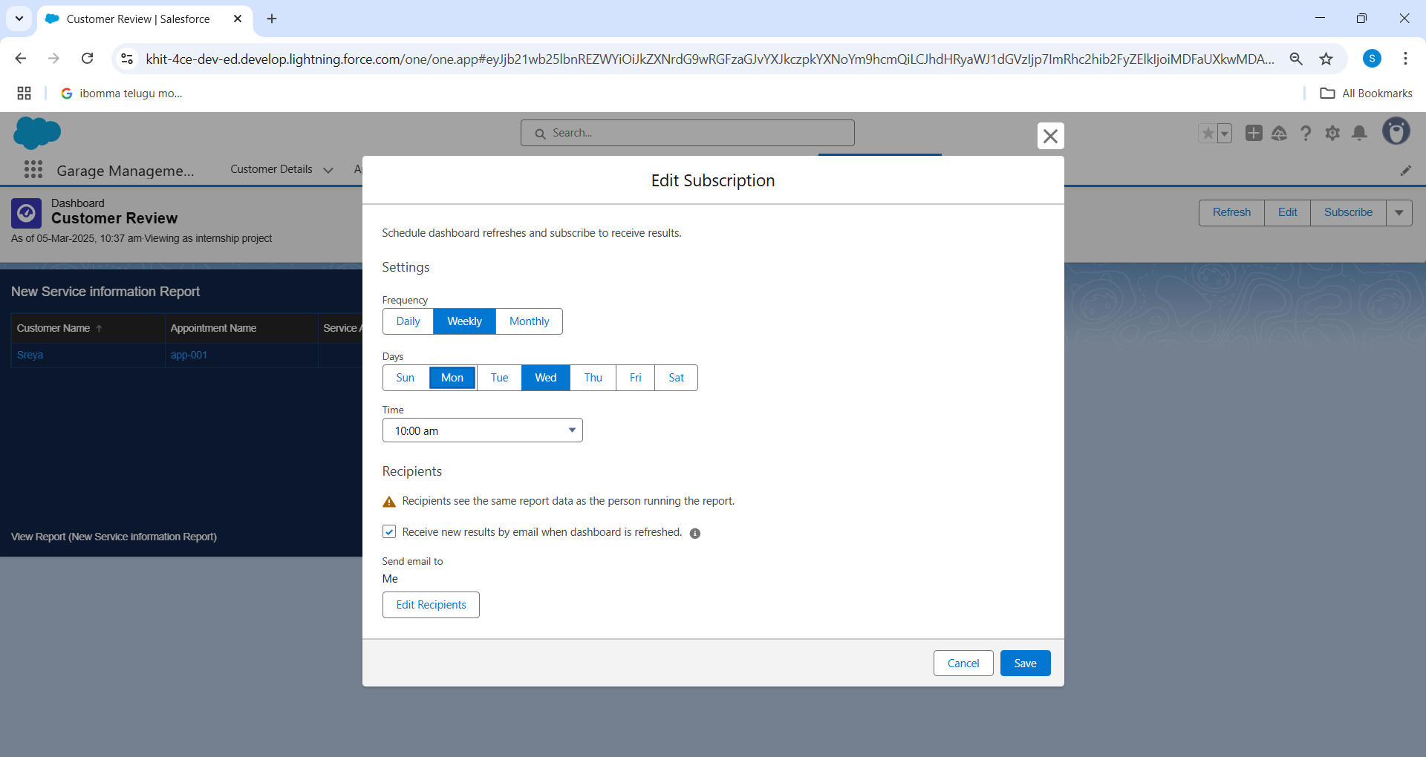

**Milestone 17 :** User Adoption

**Creation Record:**

1. To create a record in the follow objects follow these steps
2. Click on the app launcher located at the left side of the screen.
3. Search for “ **Garage Management**” and click on it.
4. Click on the “ **Consumer details** tab”.
5. Click on new and fill the details as shown below figs, and click save.
6. Now, Create the Appointment Record
7. Click on the “**Appointment**tab”.
8. Enter the customer details as created, while entering Appointment Date enter the date less than the created date.
9. Match the validation while entering the vehicle number plate.
10. Select the services you need.
11. Click on save to see the Service Amount.
12. Now, Create a service Record
13. Click on the “**Service record** tab”.
14. Enter the Appointment, and started is selected as default.
15. Click on save.
16. Open the record and click on Quality check status as true.
17. Click on save.
18. Now automatically Service status will be moved to completed

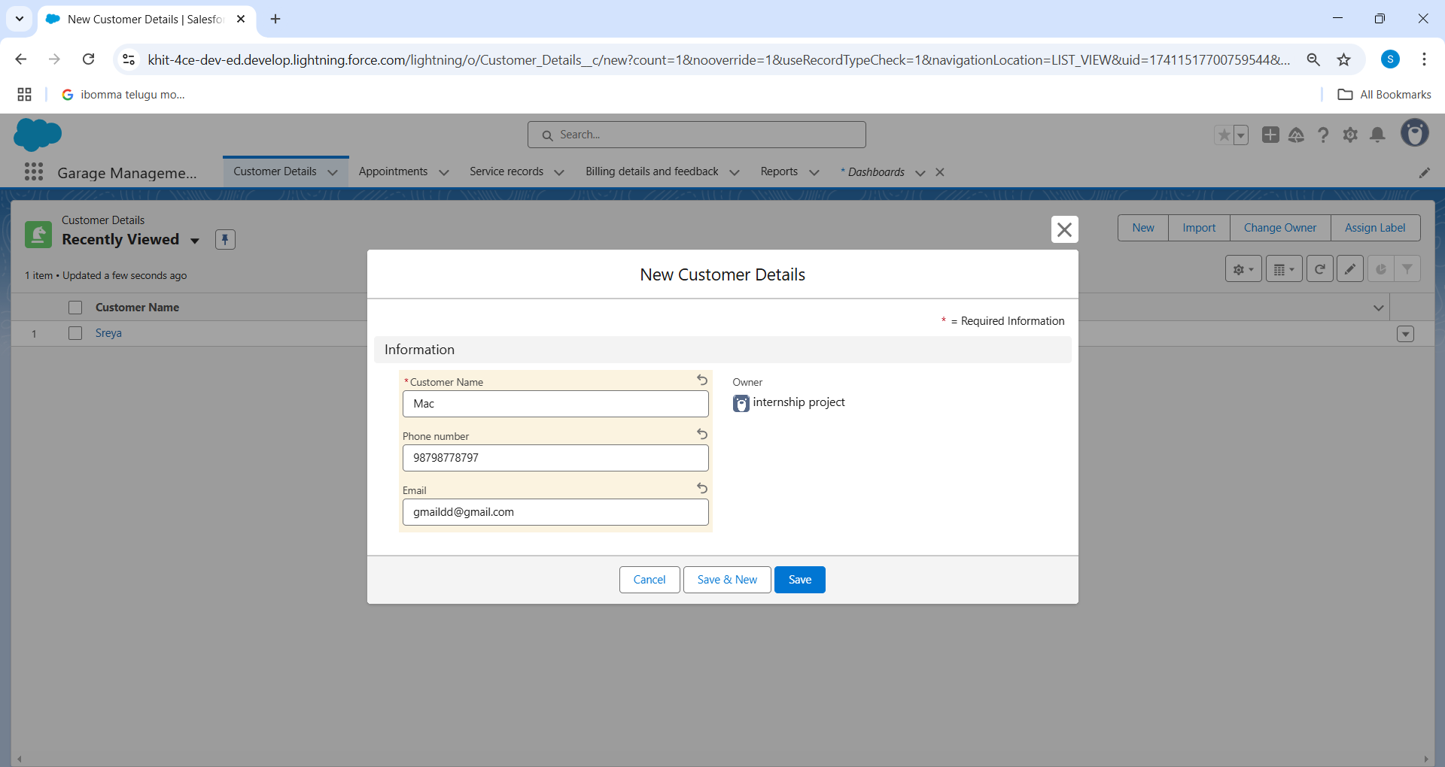

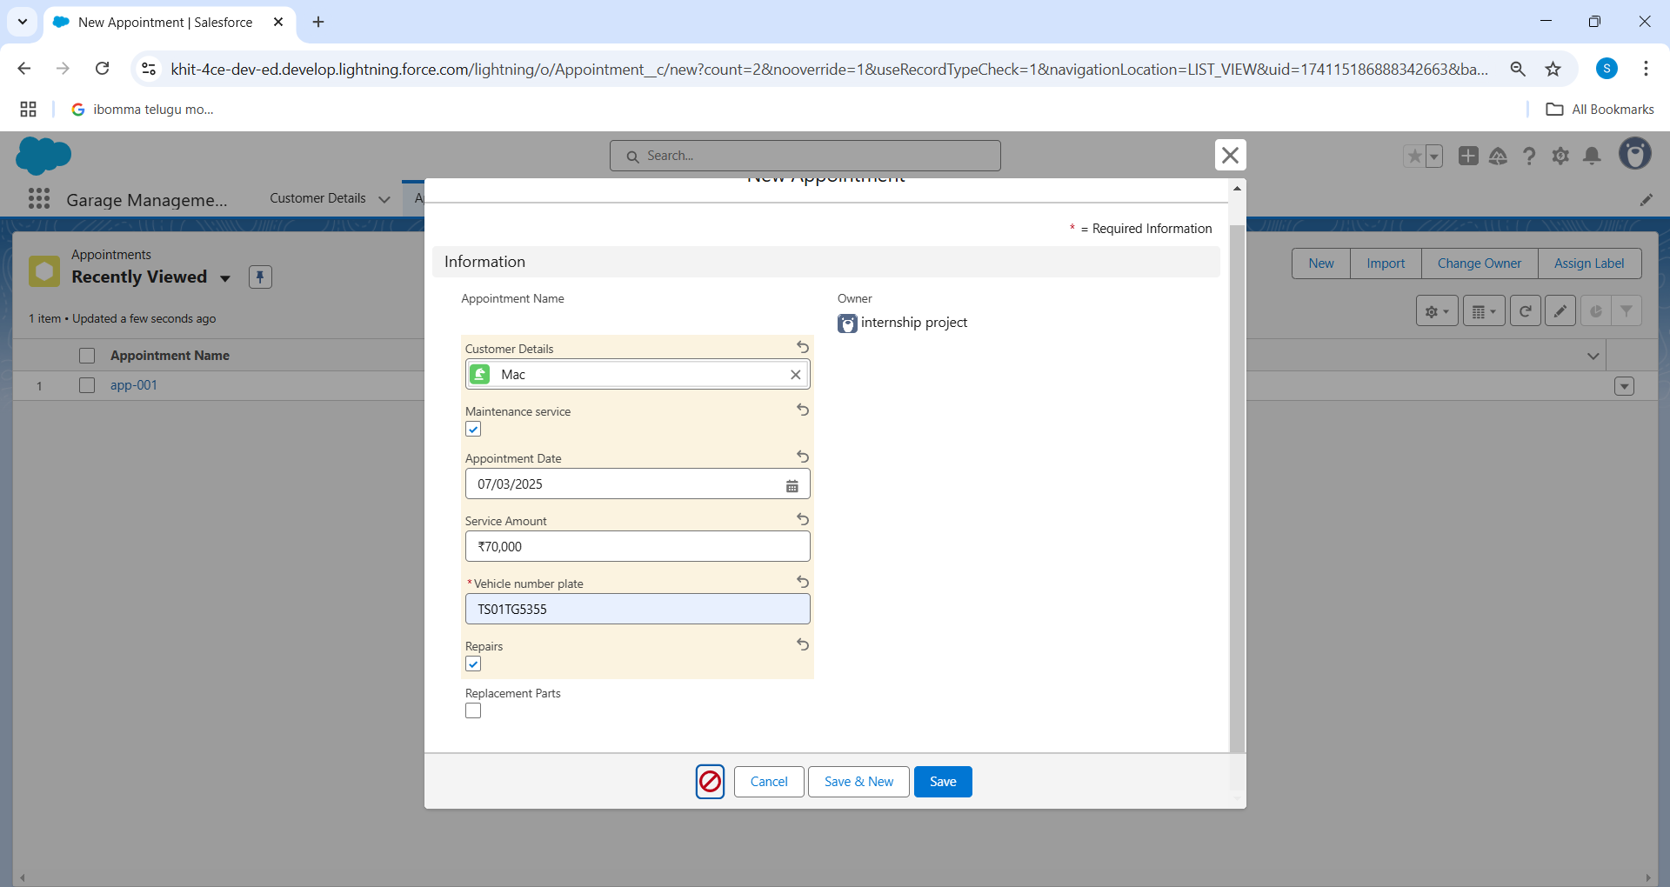

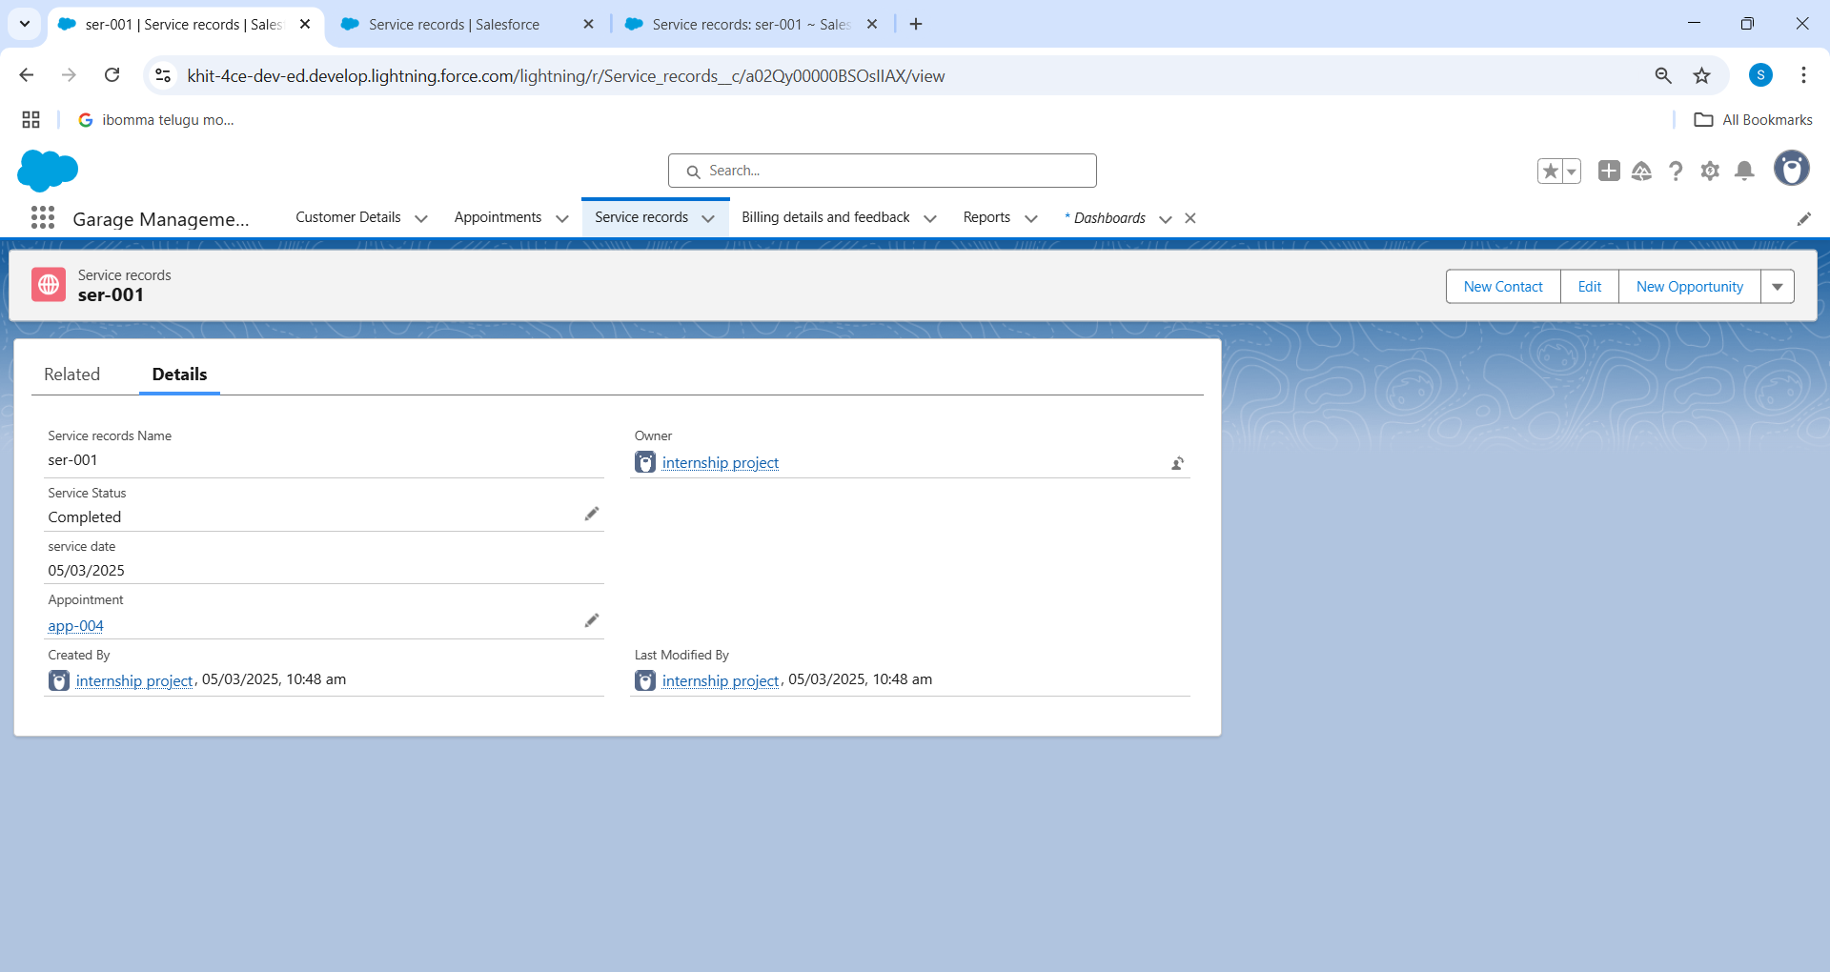

**Conclusion :** The Garage Management System (GMS) has proven to be an indispensable asset for automotive repair facilities, revolutionizing the way they operate and interact with customers. By providing a comprehensive suite of tools that streamline everything from customer and vehicle management to service tracking, inventory control, financial oversight, and staff coordination, GMS enables garages to optimize their workflows, reduce operational costs, and enhance service quality. The system's intuitive interface ensures that both staff and customers can navigate it with ease, fostering a seamless experience that builds trust and loyalty. Additionally, GMS's robust data analytics and reporting capabilities offer valuable insights, empowering garage owners to make informed decisions that drive growth and success in a highly competitive market.

The implementation of the Garage Management System is a strategic move towards a more efficient and customer-centric approach to automotive repair. It equips garages with the tools they need to deliver exceptional service, manage operations smoothly, and build strong, lasting relationships with their customers. In an industry that is constantly evolving, GMS is not just a beneficial addition but a necessary step for businesses aiming to stay ahead and thrive in the modern market landscape.